

HR/Payroll Guide
Cyber Recruiter Version 6.8
December 2008

Table of Contents
Getting Started 6
Terms 6
Available Interfaces 7
Sage Abra HRMS “Abra” –Dynamic Link 8
Establishing Connectivity 8
Linking to Foxpro 8
Admin Setup – Enabling Abra 8
Step 1: Setting Global Defaults 8
Step 2: Setting the Data Source 10
Step 3: Defining Misc Fields 10
Daily Use – Transferring Applicants to Abra 11
Step 1: Find the Applicant 11
Step 2: Identify the Company in Abra 11
Step 3: Enter Employee Identifiers 12
Step 4: Verify Information 12
Step 5: Send information 14
Where the Data Goes 14
General 14
Demographics 15
Personal Information 16
Job / Salary 16
Payroll Info 18
Payroll Processing 18
Sage Abra HRMS “Abra” –File Export 20
Establishing Connectivity 20
ODBC Connetion to Foxpro 20
ODBC Connetion to SQL 21
Installing Cyber Recruiter to Abra Import Tool 21
Admin Setup – Enabling Abra 22
Step 1: Setting Global Defaults 22
Step 2: Defining Misc fields 23
Step 3: Verifying Code Tables 23
Daily Use – Transferring Applicants to Abra 23
Step 1: Prepare the Applicant & Verify Required Fields 23
Step 2: Add Record to the Export File 24
Step 3: Generate the Export File 24
Step 4: Verify Results 25
Step 5: Prepare Export List for Next Batch 26
Step 6: Import into Abra 26
Where the Data Goes 26
General 26
Demographics 27
personal Information 28
Job / Salary 28
Payroll Info 29
Payroll Processing 30
ADP –File Export 31
Admin Setup – Enabling ADP HR 31
Step 1: Setting Global Defaults 31
Step 2: Verifying Code Tables 32
Daily Use – Transferring Applicants to ADP 33
Step 1: Prepare the Applicant & Verify Required Fields 33
Step 2: Add Record to the Export File 34
Step 3: Generate the Export File 34
Step 4: Verify Results 35
Step 5: Prepare Export List for Next Batch 36
Step 6: Import into ADP 36
DAta Mapping- ADP 37
Deltek Costpoint –File Export 42
Admin Setup – Enabling the costpoint interface 42
Step 1: Setting Global Defaults 42
Step 2: Building Code Tables 43
Step 3: Setting Data Options 43
Step 4: Setting Costpoint Defaults 45
Step 5: Define Required Fields 45
Daily Use – Transferring Applicants to Costpoint 46
Step 1: Prepare the individual & Verify Required Fields 46
Step 2: Complete Costpoint Page 46
Step 3: Add Record to the Export File 47
Step 4: Generate Export File 48
Step 5: Verify Results 48
Step 6: Prepare Export List for Next Batch 49
Step 7: Import into Costpoint 50
Data Mapping - Costpoint 50
Deltek Vision –Dynamic link 52
Establishing Connectivity 52
Admin Setup – Enabling Deltek Vision 52
Step 1: Setting Global Defaults 52
Daily Use – Transferring Applicants to Deltek Vision 54
Step 1: Find the Applicant 54
Step 2: Enter Employee Identifiers 55
Step 3: VERIFY Information 55
Where the Data Goes 57
GCS Premier –File Export 62
Admin Setup – Enabling GCS Premier HR 62
Step 1: Setting Global Defaults 62
Step 2: Verifying Code Tables 63
step 3: Define Required Fields 63
Daily Use – Transferring Applicants to GCS Premier 65
Step 1: Prepare the Applicant & Complete Required Fields 65
Step 2: Add Record to the Export File 66
Step 3: Generate Export File 66
Step 4: VERIFY Results 67
Step 5: Prepare Export List for Next Batch 68
Step 6: Import into GCS premier 69
Data Mapping 70
Great Plains –File Export 73
Admin Setup – Enabling Great Plains 73
Step 1: Setting Global Defaults 73
Step 2: Verifying Code Tables 74
Daily Use – Transferring Applicants to Great Plains 75
Step 1: Prepare the Applicant & Verify Required Fields 75
Step 2: Add Record to the Export File 76
Step 3: Generate Export File 76
Step 4: Verify Results 77
Step 5: Prepare Export List for Next Batch 78
Step 6: Import into great Plains 78
Data Mapping 79
HR Office – File Export 82
Admin Setup – Enabling HR Office HR System 82
Step 1: Setting Global Defaults 82
Step 2: Verifying Code Tables 83
Daily Use – Transferring Applicants to HR Office 83
Step 1: Prepare the Applicant & Verify Required Fields 83
Step 2: Add Record to the Export File 84
Step 3: Generate Export File 84
Step 4: Verify Results 85
Step 5: Prepare Export List for Next Batch 86
Step 6: Import into HR Office 86
Data Mapping 86
Personal Information Fields 86
Job Information Fields 87
HR-XML 89
Admin Setup – Enabling HR-XML HR System 89
Step 1: Turning HR-XML On 89
Step 2: Verifying Code Tables 90
Daily Use – Transferring Applicants to HR-XML 90
Step 1: Prepare the Applicant & Verify Required Fields 90
Step 2: Add Record to the Export File 90
Step 3: Generate Export File 91
Step 4: Verify Results 92
Step 5: Prepare Export List for Next Batch 92
Step 6: Import into HR-XML SupportED Product 93
Appendix A – Importing Code Tables 94

Getting Started
Thank you for purchasing the Cyber Recruiter Applicant Tracking System from Visibility Software, LLC. This guide is designed to provide Administrators of the system the knowledge needed to configure integration to the various HR or Payroll systems your organization may use and provide the daily user of Cyber Recruiter with the necessary knowledge to transfer information from Cyber Recruiter to your HR or Payroll system. If your organization has more than one system (ADP for Payroll and Abra for HR, for example) more than one of these integration paths may be activated.

Terms
Integrate: Products which integrate typically require no further action on a user’s part outside of setup in order to move data from one product to another. For example, if pressing the ‘Save’ button in one system adds a record in another system then the two systems are ‘integrated’.

Interface: Products which interface require an action to be performed by a user on a routine basis to keep the two systems in sync. Links between Cyber Recruiter and your HR/Payroll system will be an interface and will require an action by a user of your system.

Interface by File Export: Cyber Recruiter will gather information and consolidate it into a file which is exported from Cyber Recruiter and will be imported into the HR/Payroll system. This process is a multiple step process which includes completing a page in Cyber Recruiter with specific information for the HR/Payroll system, exporting the file and then importing the file into the HR/Payroll system.
This process will have two pages to complete during the daily use of this interface. The first page is stored in the Applicant file. The second is accessed under the Applicant menu item. Each page will reference the HR/Payroll module to which you are interfacing.

Interface by Dynamic Link: Cyber Recruiter and the HR/Payroll system are connected via an ODBC or OLE DB connection which allows for a page in Cyber Recruiter to collect information and push the information into the HR/Payroll system. This is a one step process; however it does require direct connection between the two systems.
This process will have one page to complete during the daily use of this interface. The page will be under the Applicant menu item. The page will reference the HR/Payroll module to which you are interfacing.

Admin Setup: Instruction for the Administrator of the system which will require access to the Admin menu item. Each interface has a section that gives more information about what is transferred and lists all the user-defined code tables for each system. The first part of this manual is indicates how to setup of the interface. Various ones might have appendices that will provide further information.
Each interface will have a component which must be configured under “Admin > Links > Pre-Defined Links”. For interfaces which are exports (see definition above) an additional component will need to be configured under “Admin > Codes” under the specific HR/Payroll module.

Daily Use: Instruction for the everyday user of Cyber Recruiter who will need to incorporate these pieces into his/her daily recruiting processes. It walks the User through completing the data to the Applicant File, exporting the file and what to look for by ways of errors/successful transfers.

Available Interfaces
Dynamic Links
- Sage Abra HRMS (FoxPro & SQL)
- Deltek Vision
File Export
- Sage Abra HRMS (FoxPro & SQL)
- ADP (Payroll Only)
- Deltek CostPoint 5.0
- Deltek CostPoint 6.0
- Deltek CostPoint 6.1
- Deltek GCS Premier
- Great Plains
- HR Office
- HR XML

Sage Abra HRMS “Abra” –Dynamic Link

Establishing Connectivity
The process for transferring new hires from Cyber Recruiter to Abra using the dynamic requires either (1) knowledge of the SQL information to connect to the Abra database or (2) establishing a connection to the Foxpro database. If you have the SQL information, skip the section below and move directly to the section on setting up the Admin pieces in Cyber Recruiter.

Linking to Foxpro
From within Abra Suite
Find the path to the Abra Suite Data Directory
Log in to Abra Suite
Go to Help / Abra Suite
Click the System Information tab
Write down the Data Path
On the Cyber Recruiter Web Server
Ensure that Abra Suite has an assigned path viewable by this computer
Find the web.config file in the Cyber Recruiter root installation folder and open it in Notepad.
In the <AppSettings> section of the web.config file, add the following line
<add key="AbraPath" value="C:\Abra\Programs\Data" />
  - Replace “C:\Abra\Programs\Data” with the full path to your Abra Suite data directory
Note: Under Admin / Links / Pre-Defined Links in Cyber Recruiter, the FoxPro Data Source field can be left blank. It is used only in the case of using ODBC to connect to your Abra data directory (instead of the method outlined above). It exists only as a backup to the above method and shouldn’t be used unless a member of Cyber Recruiter’s support staff instructs you to do so.

Admin Setup – Enabling Abra
Once the connection information is obtained the following steps in the admin section should be taken to activate this interface.

Step 1: Setting Global Defaults
Admin > Links > Pre Defined Links > Abra Suite

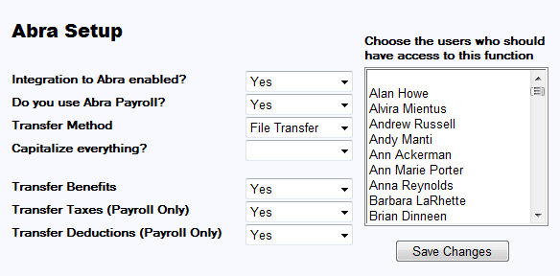

Question | Response | Result
Integration to Abra enabled? | Yes | Abra-specific page and menu items will be added in Cyber Recruiter.
Integration to Abra enabled? | Yes | Action Needed: Highlight the Users in the Drop-Down List who should have access to the Abra-specific functions in Cyber Recruiter. Hold the CRTL key down to select more than one User.
Integration to Abra enabled? | No | Users will not see any references to Abra in Cyber Recruiter.
Do you use Abra Payroll? | Yes | All Abra Payroll-specific fields will appear in Cyber Recruiter during the transfer process.
Do you use Abra Payroll? | No | Only HR Related fields will appear during the transfer process.
Transfer Method | FoxPro, SQL or File Transfer. See step 2 for FoxPro or SQL. See next section for File Transfer
Capitalize everything? | Yes | All data transferred to Abra will appear in capitalized lettering.
Capitalize everything? | No | All data transferred to Abra will appear as it was entered in Cyber Recruiter.
Transfer Benefits | Yes | Upon transferring the file into Abra, the system will verify any benefits set to ‘Auto Add’ and compare against the qualifications. If the individual meets the pre-set qualifications, the benefit will be added.
Transfer Benefits | No | No benefits will be added when transferring the file.
Transfer Deductions | Yes | Upon transferring the file into Abra, the system will verify any deductions set to ‘Auto Add’ and add those deductions.
Transfer Deductions | No | No deductions will be added when transferring the file.
Transfer Taxes | Yes | Upon transferring the file into Abra, the system will verify any taxes set to ‘Auto Add’ and compare against the home state and timesheet work code to determine which taxes should be added.
Transfer Taxes | No | No taxes will be added when transferring the file.

Step 2: Setting the Data Source
Using the information obtained from the section on establishing connectivity complete the following setup pieces.

Question | Answer | Result
What version of Abra do you use? | FoxPro | Cyber Recruiter will reference the web config file to locate the Abra data for the file transfer.
What version of Abra do you use? | SQL | Cyber Recruiter will expect to post to an SQL database for the transfer.  Additional Action Needed: Using the tabs at the bottom of the page, enter in the SQL information to connect to your Abra system. Should you wish to take an action upon completing the new hire process, enter that command in the ‘Advanced’ tab.

Step 3: Defining Misc Fields
Identify any fields currently in Cyber Recruiter which can be passed to Abra’s misc. fields. Use the drop-down menus to identify the location of the information in Cyber Recruiter.

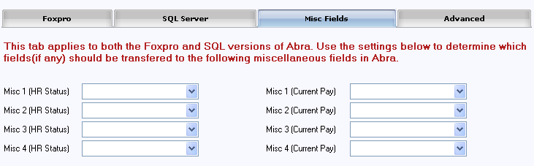

Daily Use – Transferring Applicants to Abra
The transfer process (Cyber Recruiter to Abra) replaces the New Hire Action in Abra. When an applicant needs to be ‘hired’ into Abra, this is done one at a time from the Applicants > Hire into Abra Suite process in Cyber Recruiter.

Step 1: Find the Applicant
If you are using the option to ‘Process New Hire’ you can skip this step as the system will already know which individual you are working with.

From the Applicant’s menu, select Hire into Abra Suite. Find the desired individual to move into Abra by identifying the individual via his/her Last Name, Email, Applicant ID #, Overall Status or Range (Application Date).

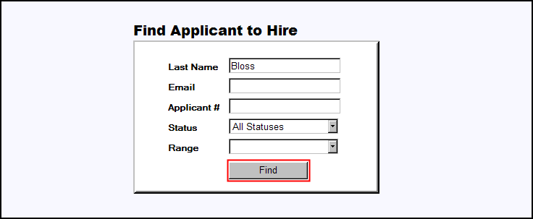

Once the Applicant is found, select the Applicant by clicking on the blue hyperlink Applicant Name.

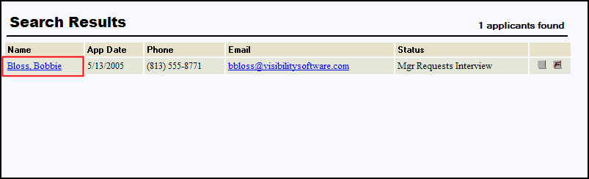

Step 2: Identify the Company in Abra
Should there be more than one company set up in Abra, choose the appropriate company for which this individual is being hired. This will dictate last employee number used and the drop-down options in the follow screens.

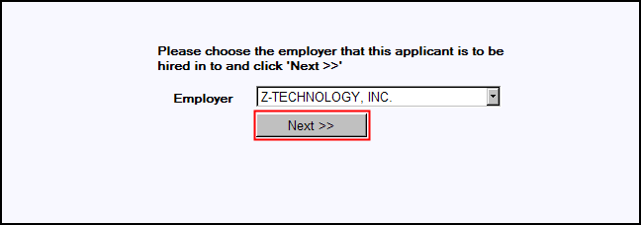

Step 3: Enter Employee Identifiers
Enter the Employee Number (unique identifier for Abra) and the Hire Date for this employee. If employee number in Abra is a numeric value, the Last Employee # will be generated to help determine what the next number should be. If the employee number is alphanumeric, Cannot Determine will show instead.

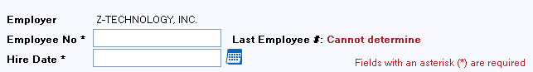

Step 4: Verify Information
Make any necessary changes to the demographics information captured by Cyber Recruiter. First Name, Last Name, and State of residency are required fields on this page. Remember that the email address that is being passed over to Abra should be the new corporate email address if you are planning on emailing from Abra using Abra Alerts or Abra AWC.

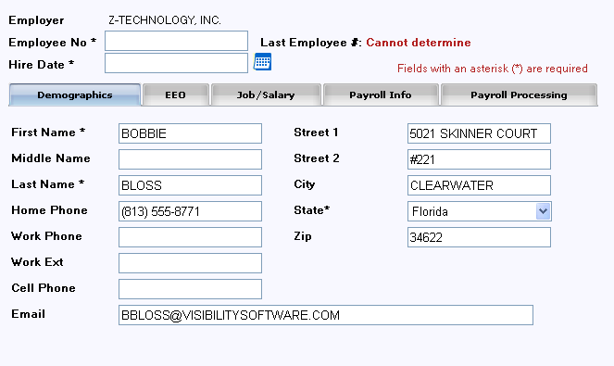

Make any necessary changes to the personal data information captured by Cyber Recruiter. Social Security Number is required on this page. Drop-down options are compared against what is currently set in Abra. If the code used in Cyber Recruiter does not match what is set in Abra, the field will not automatically populate.

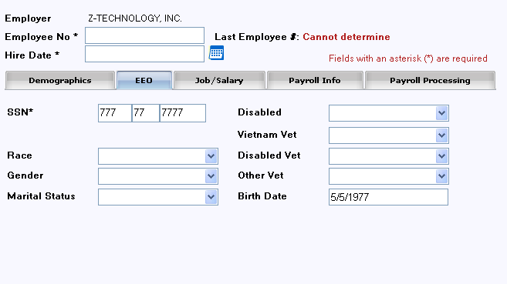

All fields on this page pull directly from Abra and need to be completed to send over a full record for the new employee. Pay Frequency and Normal Hours are generated based on the defaults set in Abra for the company selected at the beginning of the transfer process. Annual and Hourly Salary numbers are dependent on each other and the pay frequency and normal hours. Job Code and Job Title are dependent on each other. Salaried/Hourly and 1-9 Status fields are required on this page. Drop-down options are compared against what is currently set in Abra.

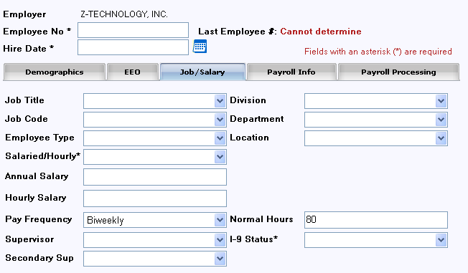

If the payroll module in Abra is activated, additional information is needed when processing a new hire. Enter the necessary information to complete this employee’s payroll record.

Defaults:
Payroll Status Active (changing this will affect the payroll process)
Job Type R-Regular (changing this will affect the 941)
EIC Filing Status Not Eligible (change this only if the employee is eligible for EIC)
Statutory No (change this only if the person should not have any taxes withheld)

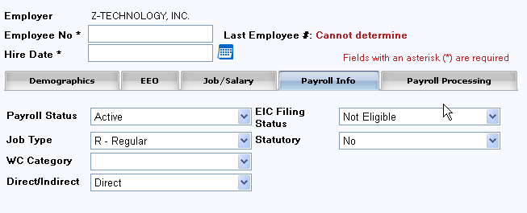

If the payroll module in Abra is activated, additional information is needed when processing a new hire. Enter the necessary information to complete this employee’s payroll record for processing. Pay Group will list the available pay groups based on the company selected, Regular and Holiday earnings are used if this person will receive an automatic timesheet for payroll. Time Sheet Work Code should be the state in which the employee will be working and will determine the state to which unemployment taxes will be calculated.

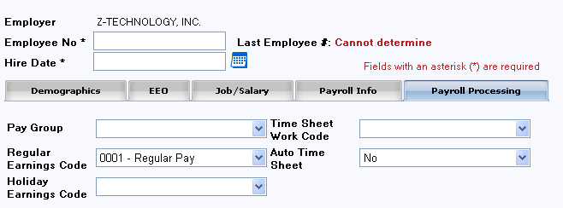

Step 5: Send information
Press the Save Changes button in the system to forward the information to the Abra database. The information can now be located in Abra. The information is NOT saved in Cyber Recruiter.

Where the Data Goes
This section links the tabs used in the Abra Data Transfer of Cyber Recruiter to the Abra HR & Payroll system. It is also important to note that the interface:

- Checks the benefits setup to determine if any automatically added benefits should be add to this employee’s record
- Passes formal education to the Education screen in Abra
- Passes previous employment to the Previous Employment screen in Abra
- Passes skills to the Skills screen in Abra (skills code must be the same in the two systems)

General

Field Name | Abra Screen and Field | Abra Database Name
Company | Each Screen | P_company
Employee ID | Each Screen | P_empno
Hire Date | HR Status / Original Hire  HR Status / Last Hire  HR Status / Seniority Date  Current Job / Job Date  Current Pay / Pay Effective Date | P_orighire  P_lasthire  P_sendate  P_jobdate  P_paydate
 | Current Job / Employee Status | P_active

Demographics

Information that appears on this page is pulled from the Cyber Recruiter Applicant Demographics Page. It should be verified as the employee is hired into Abra.

Field Name | Abra Screen and Field | Abra Database Name
First Name | Demographics / First Name | P_fname
Middle Name | Demographics /Middle Name | P_mi
Last Name | Demographics / Last Name | P_lname
Home Phone | Demographics / Home Phone | P_hphone
Work Phone | Demographics / Business Phone | P_busphone
Work Ext. | Demographics / Extension | P_busext
Cell Phone | Demographics / Cell Phone | P_cellphone
Email | Demographics / Email | P_email
Street 1 | Demographics / Home Street 1 | P_hstreet1
Street 2 | Demographics / Home Street 2 | P_hstreet2
City | Demographics / Home City | P_hcity
State | Demographics / Home State | P_hstate
Zip | Demographics / Home Zip | P_hzip

Personal Information

Information that appears on this page is pulled from the Cyber Recruiter Applicant Demographics Page under the EEO section. It should be verified as the employee is hired into Abra.

Field Name | Abra Screen and Field | Abra Database Name
SSN | Demographics / Social Security Number | P_ssn
Race | Demographics / Ethnic Origin | P_race
Gender | Demographics / Gender | P_sex
Marital Status | Demographics / Marital Status | P_married
Birth Date | Demographics / Birth Date | P_birth
Disabled | Demographics / Disabled | P_handicap
Vietnam Vet | HR Status / Vietnam Era Veteran | P_Vietnam
Disabled Vet | HR Status / Disabled Veteran | P_disvet
Other Vet | HR Status / Other Eligible Veteran | P_othervet

Job / Salary

Information that is captured on this page is pulling from the Abra drop-down options. All information needs to be verified and selected from the drop-down options.

Field Name | Abra Screen and Field | Abra Database Name
Job Title | Current Job / Job Title | P_jobtitle  P_jobcode (based on Abra setup)  P_eeoclass (based on Abra setup)  P_exempt (based on Abra setup)  P_jobgroup (based on Abra setup)  P_salgrade (based on Abra seteup)
Employee Type | Current Job / Employee Type | P_employ
Salaried/Hourly | Current Pay / Salaried Hourly | P_salhour
Annual Salary | Current Pay / Annual Pay | P_annual  P_salary (based on pay frequency and normal hours)
Hourly Salary | Current Pay / Unit Pay Rate | P_unitrate
Pay Frequency | Current Pay / Pay Frequency | P_payfreq
Supervisor | Current Job / Supervisor | P_supervis
Secondary Sup | Current Job / Manager | P_supervis2
Division/  Department/  Location/ | Current Job / Division (based on Abra Setup)  Current Job / Department (based on Abra Setup)  Current Job / Location (based on Abra Setup) | P_level1  P_level2  P_level3
Normal Hours | Current Pay / Hours Per Pay Period | P_normunit
I-9 Status | HR Status / I-9 Verification Status | P_i9verif

Payroll Info

Information that is captured on this page is pulling from the Abra drop-down options. All information needs to be verified and selected from the drop-down options. This tab will only be activated if the set up in the Cyber Recruiter Admin section is set to track payroll information for Abra.
Field Name | Abra Screen and Field | Abra Database Name
Payroll Status | Payroll Status / Payroll Status | P_paystat
Job Type | Current Job (Pay) / Job Type | P_emptype
WC Category | Current Job (Pay) / Workers Comp | P_workcomp  P_workrate (based on Abra setup)
Direct/Indirect | Current Job (Pay) / Direct | P_direct
EIC Filing Status | Tax Withholding / EIC | P_eicmstat
Statutory | Tax Withholding / Statutory | P_statute

Payroll Processing

Information that is captured on this page is pulling from the Abra drop-down options. All information needs to be verified and selected from the drop-down options. This tab will only be activated if the set up in the Cyber Recruiter Admin section is set to track payroll information for Abra.

Field Name | Abra Screen and Field | Abra Database Name
Pay Group | Payroll Status / Pay Group | P_paygroup
Regular Earnings Code | Payroll Status / Regular Pay | P_autoreg
Holiday Earnings Code | Payroll Status / Holiday Pay | P_autohol
Time Sheet Work Code | Tax Withholding / Timesheet Work Code | P_workcode
Auto Timesheet | Payroll Status / Auto Timesheet | P_autopay

Sage Abra HRMS “Abra” –File Export

Establishing Connectivity

ODBC Connetion to Foxpro

- Find out the path to your Abra Suite Data Directory. If you do not know it take the following steps
  - Login to Abra Suite
  - Go to Help/About Abra Suite
  - Click the System Information tab
  - Write down the Data Path
- Go to Start/Settings/Control Panel
- If using Windows 2000, open the Administrative Tools folder. If any other version of Windows, go to Step 4
- Double-click the Data Sources (ODBC) or 32-bit Data Sources icon (you may have either).
- Go to the System DSN tab.
- Click Add, double-click Microsoft Visual FoxPro Driver.
- Type in a Data Source Name. It can be anything, but you must remember the name of it. Common choices for names are LiveAbra, AbraData, or LiveAbraData.
- You may leave the Description blank.
- Choose Free Table Directory.
- Click Browse and find the folder on your network where your Abra Suite data directory resides and click OK.
- Click the Options button.
- Uncheck the Deleted box.
- Click OK to close the ODBC Visual FoxPro Setup box.
- Click OK to close the ODBC Data Source Administrator box.
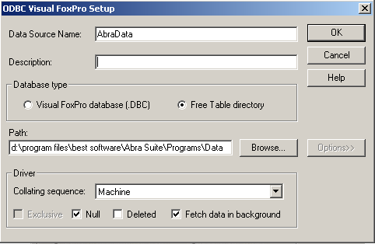

ODBC Connetion to SQL
Below are the steps to follow to create an ODBC Source to your Abra Suite SQL database. If you have troubles, you may need to contact one of your IT personnel.
- Go to Start/Settings/Control Panel
- If using Windows 2000, open the Administrative Tools folder. If any other version of Windows, go to Step 3
- Double-click the Data Sources(ODBC) or 32-bit Data Sources icon (you may have either).
- Go to the System DSN tab.
- Click Add, double-click SQL Server.
- Type in a Name. It can be anything, but you must remember the name of it. Common choices for names are LiveAbra, AbraData, or LiveAbraData.
- You may leave the Description blank.
- Enter the name of the Abra SQL Server and click Next.

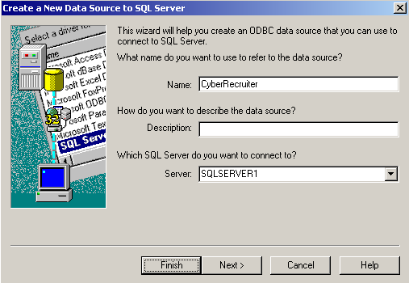
Check the ‘With SQL Server authentication using a login ID and password enter by the user’ radio button
Check the ‘Connect to SQL Server to obtain default settings for the addition configuration options’ checkbox

Installing Cyber Recruiter to Abra Import Tool
- Download the import utility from www.VisibilitySoftware.com/CRUpdates/AbraImport.zip into a blank folder on any machine that has the .NET Framework 1.1 installed and has access to the Abra Suite data (either Foxpro or SQL).
- Unzip the downloaded file into that same folder, there is only one .exe inside.
- Create an ODBC connection from that machine to the Abra Suite data. See the previous section for information on setting up connections to FoxPro or SQL.
- Launch the import utility by double-clicking AbraImport.exe.
- Click the Setup button
- Choose whether you use Abra Foxpro or SQL.
- If you use Abra Foxpro, also choose whether or not you use Abra’s payroll product.
- Enter the name of the ODBC Source created in step 3 above.
- Click OK to save your changes.

Admin Setup – Enabling Abra
Once the connection information is obtained the following steps in the admin section should be taken to activate this interface.

Step 1: Setting Global Defaults
Admin > Links > Pre Defined Links > Abra Suite

Question | Response | Result
Integration to Abra enabled? | Yes | Abra-specific page and menu items will be added in Cyber Recruiter.
Integration to Abra enabled? | Yes | Action Needed: Highlight the Users in the Drop-Down List who should have access to the Abra-specific functions in Cyber Recruiter. Hold the CRTL key down to select more than one User.
Integration to Abra enabled? | No | Users will not see any references to Abra in Cyber Recruiter.
Do you use Abra Payroll? | Yes | All Abra Payroll-specific fields will appear in Cyber Recruiter during the transfer process.
Do you use Abra Payroll? | No | Only HR Related fields will appear during the transfer process.
Transfer Method | FoxPro, SQL or File Transfer. See previous section for steps regarding FoxPro or SQL.
Capitalize everything? | Yes | All data transferred to Abra will appear in capitalized lettering.
Capitalize everything? | No | All data transferred to Abra will appear as it was entered in Cyber Recruiter.
Transfer Benefits | N/A – benefits are not compared / added during the file transfer process
Transfer Deductions | N/A – deductions are not compared / added during the file transfer process
Transfer Taxes | N/A – taxes are not compared / added during the file transfer process

Step 2: Defining Misc fields
Identify any fields currently in Cyber Recruiter which can be passed to Abra’s misc. fields. Use the drop-down menus to identify the location of the information in Cyber Recruiter.

Step 3: Verifying Code Tables
Codes which are currently used in Abra need to be re-entered into Cyber Recruiter so the user exporting the information can select the correct value. These values MUST match what is currently in Abra in order for Abra to recognize the values and successfully import the file. All codes are stored under Admin > Codes > Abra.

Daily Use – Transferring Applicants to Abra

Step 1: Prepare the Applicant & Verify Required Fields
Once the Abra interface is enabled, an Abra Page in the Applicant File will appear for any users specified in the setup. This page will appear for all applicants but should only be complete for individuals who should be sent over to Abra. To start the process, find the individual’s record that will be exported to Abra.
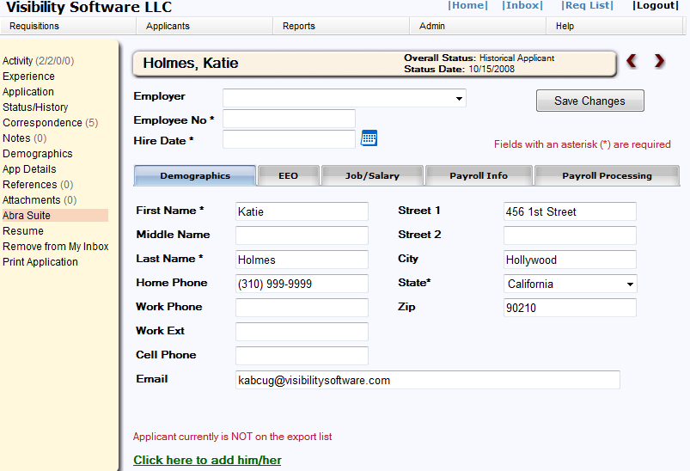
Once the individual is located, use the Abra Page to enter data that does not already exist in the Cyber Recruiter product. This information will be transferred in addition to the required pieces of information necessary for the transfer. Even though some of these fields on these tabs are not required it is good practice to fill out as much as possible to have the most complete record.

Be sure to save your changes after completing this page.

Step 2: Add Record to the Export File
Click on the green link at the bottom of the page to add this individual to the export file. The red indicator will change to indicate the individual is on the list of records to be exported. In this example, the link has not been clicked.

Step 3: Generate the Export File
After verifying and adding the Individual to the export file, from the main menu bar select Applicants > Create Abra Suite Export File to generate the export file.

The Employee ID number is pulled from the Applicant File (Employee File) > Abra Page > Employee ID Field.

This table displays the Individuals who have been added to the export file via the Applicant File > Abra Page. To add additional Individuals to the list, press the Add button and find the individual’s record. To remove individuals from the list, check the box at the end of the record line and click the Delete Selected button. Using the Select All or Deselect All links at the top will place checkmarks or remove check marks next to everyone’s record. Everyone listed here will be included in the export file.

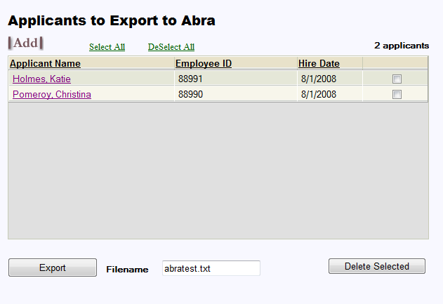

Click the Export button to create the export file. Enter the name of the file in the Filename field. Cyber Recruiter will save the last export file created. However, this file will be overwritten each time the export process is run.

Step 4: Verify Results
The page which appears allows you to verify the results and eventually to save the file generated to a network or disk location.

correcting Errors
The error log indicates that some individuals are missing information, the information for those individuals should be entered and another export performed. Click the Print link to print a report as needed and click the individual’s name to enter the file or make the necessary changes. The export process can be run as many times as needed to obtain an error free file.

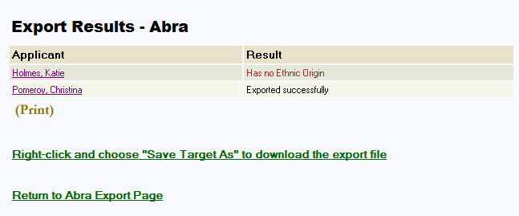

Saving the File
If the error log indicates that all individuals were Exported Successfully, right-click the indicated link and choose Save Target As to download the ASCII file created by Cyber Recruiter to the network or hard drive. Put the files in a folder on a PC that the payroll contact will have access to so that person can pull the file into Abra. Click on the Return to Abra Export Page to finish the process.

Step 5: Prepare Export List for Next Batch
To prepare the Abra Export page for the next batch of new hires, press the Select All link to place a checkmark next to the Individual’s names. Then, press the Delete Selected button to remove them from this list.

Step 6: Import into Abra
Using the Cyber Recruiter to Abra import tool, find the file generated by Cyber Recruiter and import this file into Abra.

Where the Data Goes

This section links the tabs used in the Abra Data Transfer of Cyber Recruiter to the Abra HR & Payroll system. It is also important to note that the interface.

General

Field Name | Abra Screen and Field | Abra Database Name
Company | Each Screen | P_company
Employee ID | Each Screen | P_empno
Hire Date | HR Status / Original Hire  HR Status / Last Hire  HR Status / Seniority Date  Current Job / Job Date  Current Pay / Pay Effective Date | P_orighire  P_lasthire  P_sendate  P_jobdate  P_paydate
 | Current Job / Employee Status | P_active

Demographics

Information that appears on this page is pulled from the Cyber Recruiter Applicant Demographics Page. It should be verified as the employee is hired into Abra.

Field Name | Abra Screen and Field | Abra Database Name
First Name | Demographics / First Name | P_fname
Middle Name | Demographics /Middle Name | P_mi
Last Name | Demographics / Last Name | P_lname
Home Phone | Demographics / Home Phone | P_hphone
Work Phone | Demographics / Business Phone | P_busphone
Work Ext. | Demographics / Extension | P_busext
Cell Phone | Demographics / Cell Phone | P_cellphone
Email | Demographics / Email | P_email
Street 1 | Demographics / Home Street 1 | P_hstreet1
Street 2 | Demographics / Home Street 2 | P_hstreet2
City | Demographics / Home City | P_hcity
State | Demographics / Home State | P_hstate
Zip | Demographics / Home Zip | P_hzip

personal Information

Information that appears on this page is pulled from the Cyber Recruiter Applicant Demographics Page under the EEO section. It should be verified as the employee is hired into Abra.

Field Name | Abra Screen and Field | Abra Database Name
SSN | Demographics / Social Security Number | P_ssn
Race | Demographics / Ethnic Origin | P_race
Gender | Demographics / Gender | P_sex
Marital Status | Demographics / Marital Status | P_married
Birth Date | Demographics / Birth Date | P_birth
Disabled | Demographics / Disabled | P_handicap
Vietnam Vet | HR Status / Vietnam Era Veteran | P_Vietnam
Disabled Vet | HR Status / Disabled Veteran | P_disvet
Other Vet | HR Status / Other Eligible Veteran | P_othervet

Job / Salary

Information that is captured on this page is pulling from the Abra drop-down options. All information needs to be verified and selected from the drop-down options.

Field Name | Abra Screen and Field | Abra Database Name
Job Title | Current Job / Job Title | P_jobtitle  P_jobcode (based on Abra setup)  P_eeoclass (based on Abra setup)  P_exempt (based on Abra setup)  P_jobgroup (based on Abra setup)  P_salgrade (based on Abra seteup)
Employee Type | Current Job / Employee Type | P_employ
Salaried/Hourly | Current Pay / Salaried Hourly | P_salhour
Annual Salary | Current Pay / Annual Pay | P_annual  P_salary (based on pay frequency and normal hours)
Hourly Salary | Current Pay / Unit Pay Rate | P_unitrate
Pay Frequency | Current Pay / Pay Frequency | P_payfreq
Org Level 1-5 | Based on Abra Setup | P_level1 – p_level5
Normal Hours | Current Pay / Hours Per Pay Period | P_normunit
I-9 Status | HR Status / I-9 Verification Status | P_i9verif

Payroll Info

Information that is captured on this page is pulling from the Abra drop-down options. All information needs to be verified and selected from the drop-down options. This tab will only be activated if the set up in the Cyber Recruiter Admin section is set to track payroll information for Abra.
Field Name | Abra Screen and Field | Abra Database Name
Payroll Status | Payroll Status / Payroll Status | P_paystat
Job Type | Current Job (Pay) / Job Type | P_emptype
WC Category | Current Job (Pay) / Workers Comp | P_workcomp  P_workrate (based on Abra setup)
Direct/Indirect | Current Job (Pay) / Direct | P_direct
Statutory | Tax Withholding / Statutory | P_statute

Payroll Processing

Information that is captured on this page is pulling from the Abra drop-down options. All information needs to be verified and selected from the drop-down options. This tab will only be activated if the set up in the Cyber Recruiter Admin section is set to track payroll information for Abra.

Field Name | Abra Screen and Field | Abra Database Name
Pay Group | Payroll Status / Pay Group | P_paygroup
Regular Earnings Code | Payroll Status / Regular Pay | P_autoreg
Holiday Earnings Code | Payroll Status / Holiday Pay | P_autohol
Time Sheet Work Code | Tax Withholding / Timesheet Work Code | P_workcode
Auto Timesheet | Payroll Status / Auto Timesheet | P_autopay

ADP –File Export

Admin Setup – Enabling ADP HR
The process for transferring new hires from Cyber Recruiter to the ADP product involves exporting the information to an ASCII Text file in a CSV format and importing that file into ADP product. Setup for this interface is required under Admin > Links > Pre-Defined > ADP and Admin > Codes > ADP

Step 1: Setting Global Defaults
Admin > Links > Pre Defined Links > ADP

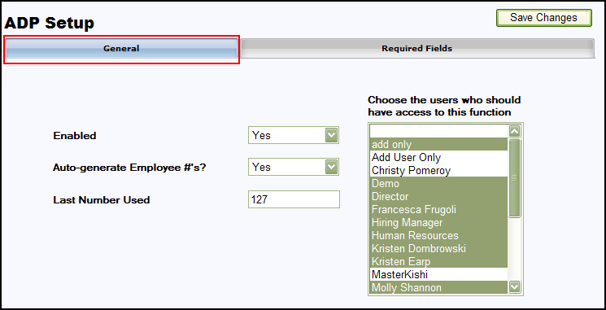

Field | Value | Result
Enabled? | Yes | All of ADP-specific pages and menu items will be added in Cyber Recruiter.
Enabled? | Yes | Additional Action Needed: Highlight the Users in the Drop-Down List who should have access to the ADP-specific functions in Cyber Recruiter. Hold the CRTL key down to select more than one User.
Enabled? | No | Users will not see any references to ADP in Cyber Recruiter.

Field | Value | Result
Auto-generate employee #s? | Yes | When viewing the ADP screen in Cyber Recruiter the system will generate the next number which should be assigned to a new employee.
Auto-generate employee #s? | Yes | Additional Action Needed: Enter the correct value for the next employee number to use in the field ‘Last Number Used’.
Auto-generate employee #s? | No | The user exporting the data will need to assign a number to the new employee

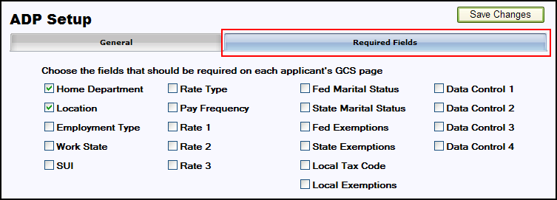

The Required Fields Tab allows the organization to select additional fields which should be required in the transfer. Check marking fields on this tab will generate an error message when a file is exported which does not have these fields completed.

Step 2: Verifying Code Tables
Codes which are currently used in ADP need to be re-entered into Cyber Recruiter so the user exporting the information can select the correct value. These values MUST match what is currently in ADP in order for ADP to recognize the values and successfully import the file.
All codes are stored under Admin > Codes > ADP. Company and any other fields specified on the ‘Required Fields’ tab must have values for the drop-down lists before the user will be able to export the information.

Daily Use – Transferring Applicants to ADP

Step 1: Prepare the Applicant & Verify Required Fields
Once the ADP interface is enabled, an ADP Page in the Applicant File will appear for any users specified in the setup. This page will appear for all applicants but should only be complete for individuals who should be sent over to ADP. To start the process, find the individual’s record that will be exported to ADP.

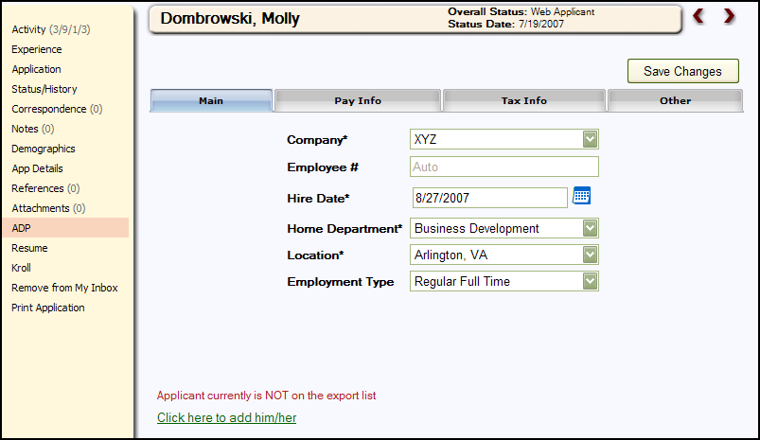

Once the Applicant is located, use the ADP Page to enter data that does not already exist in the Cyber Recruiter product. This information will be transferred in addition to the required pieces of information necessary for the transfer. Even though some of these fields on these tabs are not required it is good practice to fill out as much as possible to have the most complete record.

On the Pay Info Tab if a value is not selected for the Rate Type, the default will be ‘None’. On the Tax Info Tab if values are not selected for the following fields, the below information will be the default:

Federal Exemption = 0
Federal Marital Status = Single

Employee Status = A
Gender = N (Not specified)
Pay Group = 1 (Period End 1)

Be sure to save your changes after completing this page.

Step 2: Add Record to the Export File
Click on the green link at the bottom of the page to add this individual to the export file. The red indicator will change to indicate the individual is on the list of records to be exported. In this example, the link has not been clicked.

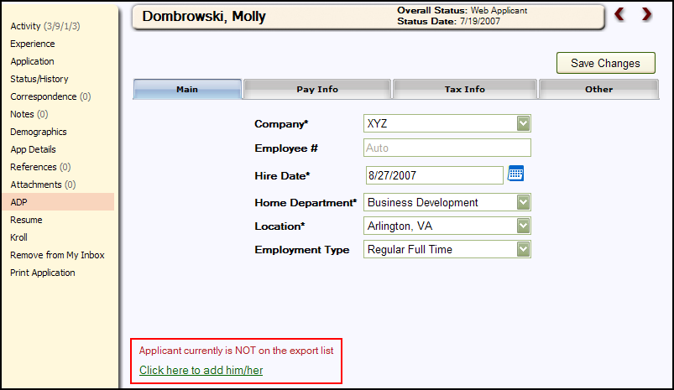

Step 3: Generate the Export File
After verifying and adding the Individual to the export file, from the main menu bar select Applicants > ADP Export to generate the export file.

The Employee ID number is pulled from the Applicant File (Employee File) > ADP Page > Employee ID Field.

This table displays the Individuals who have been added to the export file via the Applicant File > ADP Page. To add additional Individuals to the list, press the Add button and find the individual’s record. To remove individuals from the list, check the box at the end of the record line and click the Delete Selected button. Using the Select All or Deselect All links at the top will place checkmarks or remove check marks next to everyone’s record. Everyone listed here will be included in the export file.

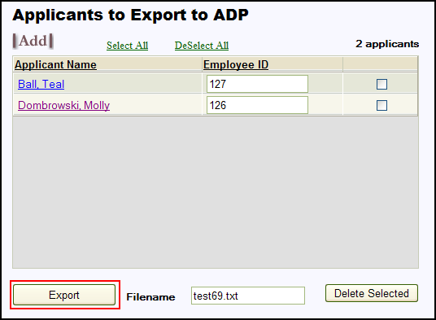

Click the Export button to create the export file. Enter the name of the file in the Filename field. The Filename field will have the following sequence: PRcccEMP.CSV. The ‘ccc’ is the company assigned code from ADP. For 2-position Company codes, use the ‘cc’ followed by an underscore ‘cc_’. Cyber Recruiter will save the last export file created. However, this file will be overwritten each time the export process is run.

Step 4: Verify Results
The page which appears allows you to verify the results and eventually to save the file generated to a network or disk location.

correcting Errors
The error log indicates that some individuals are missing information, the information for those individuals should be entered and another export performed. Click the Print link to print a report as needed and click the individual’s name to enter the file or make the necessary changes. The export process can be run as many times as needed to obtain an error free file.

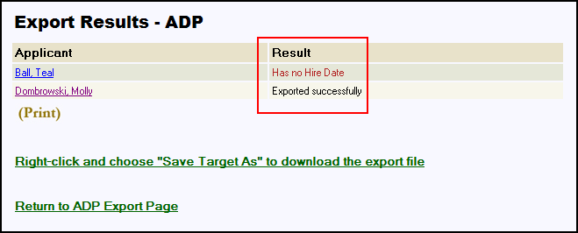

Saving the File
If the error log indicates that all individuals were Exported Successfully, right-click the indicated link and choose Save Target As to download the ASCII file created by Cyber Recruiter to the network or hard drive. Put the files in a folder on a PC that the payroll contact will have access to so that person can pull the file into ADP. Click on the Return to ADP Export Page to finish the process.

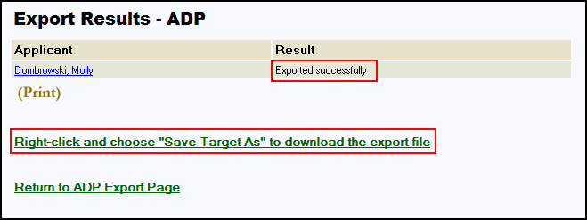

Step 5: Prepare Export List for Next Batch
To prepare the ADP Export page for the next batch of new hires, press the Select All link to place a checkmark next to the Individual’s names. Then, press the Delete Selected button to remove them from this list.

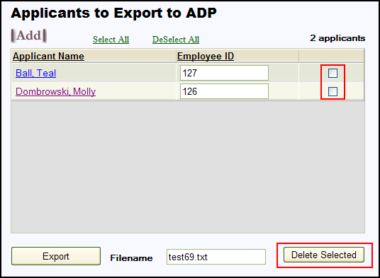

Step 6: Import into ADP
Using the tools available in ADP, browse to the file generated by Cyber Recruiter. Using the error log verify no errors occurred and the file was imported successfully.

DAta Mapping- ADP

Field Name/Description | Length | Valid Values | Requirements/Conditions
Co Code | 2-3 | A-Z, 0-9, &, - | This is the company code. The code must match the company code in the import filename, except for 2-position company codes. A 2-position code requires an underscore in the third position of the import filename. The underscore is not allowed in the Co Code field in the import file.
File # | 2-6 | 51-999999 | This is the employee number put in Cyber Recruiter.
Social Security Number | 9 (without dashes) or 11 (with dashes) | 0-9, dash  Invalid values1st digit = 8 or 91st three digits = 6661st through 3rd digits = 0004th and 5th digits = 006th through 9th digits = 0000111111111333333333123456789 | Must exactly match the value in the database for an existing employee.
Employee Last Name | 1-30 | A-Z, 0-9, space$ @ [ \ ] ^_ ` { | } ! # % & ' ( ) * + - . / : < = > ?
Employee First Name | 1-30 | A-Z, 0-9, space$ @ [ \ ] ^_ ` { | } ! # % & ' ( ) * + - . / : < = > ?
Address Line 1 | 0-20 | A-Z, 0-9, space$ @ [ \ ] ^_ ` { | } ! # % & '( ) * + , - . / : ; < = > ? "
Address Line 2 | 0-20 | A-Z, 0-9, space$ @ [ \ ] ^_ ` { | } ! # % & '( ) * + , - . / : ; < = > ? "
City | 6 or 7 (alphanumeric)  5, 9, or 10 (numeric) | Alphanumeric A-Z, 0-9, dash. Format must be ANANAN or ANA-NAN.  Numeric 0-9, dash. Format must be: NNNNN,NNNNNNNNN or NNNNN-NNNN
State Postal Code | 2 | Valid postal abbreviation
ip Code | 6 or 7 (alphanumeric)  5, 9, or 10 (numeric) | AlphanumericA-Z, 0-9, dashFormat must be ANANAN or ANA-NAN.  Numeric0-9, dashFormat must be: NNNNN,NNNNNNNNN or NNNNN-NNNN
Home Phone Number | 10 | A dash is permitted between positions 3 and 4.  Paired parentheses are permitted around positions 1-3. | If a Home Area Code value is not in the header record, the length must be 10.
Gender | 1 | M – Male  F – Female  N – Not specified
Home Department | 3 or 6, depending on company setup | A-Z, 0-9, comma/ $ . - | Table Validation Validates to company’s Department table unless importing with validation override is selected.
Location Code | 1-5 | A-Z, 0-9, space$ @ [ \ ] ^_ ` { | } ! # % & ' ( ) * + , - . / : ; < = > ? " | Table Validation Validates to company’s Location table unless importing with validation override selected.
Rate Type | 1 | H – Hourly  S – Salary  D – Daily  N – None | When using a Rate Type code other than N (None), the employee must have a rate amount in the import file.
Rate 1 Amount |  | Salary Rate Types  Min: -99999.99  Max: 99999.99  Hourly or Daily Rate Types  Min: -999.9999  Max: 999.9999 | If the employee’s Rate Type code is N (None), value must be 0 or blank.  Cannot be blank if the employee’s Rate Type code is changed to S (Salary), H (Hourly), or D (Daily).  Salary Rate Types If the company is set up with a value in the Salary Rate Limit field and the rate type is hourly; a warning is issued if the amount exceeds that value. A valid amount is added to the database anyway.  Hourly Rate Types If the company is set up with a value in the Hourly Rate Limit field and the rate type is hourly, a warning is issued if the amount exceeds that value. A valid amount is added to the database anyway.
Pay Frequency Code | 1 | W – Weekly  B – Biweekly  S – Semimonthly  M – Monthly  D – Daily  5 – 5.2 weeks  2 – 2.6 weeks  4 - 4 weeks
Hire Status | 1 | A – Active  L - Leave of Absence  T – Terminated  D - Deceased
Hire Date | 6-10 | Same as Adjusted Service Date | Must be a valid date.
Birth Date | 6-10 | Format is m/d/yy  Where m is a 1 or 2-digit month (1-12)d is a 1 or 2-digit day (1-31) yy is a 2- or 4-digit year (1900-2199)  A slash is required if month and/or day are single-digit entries  If a 6-digit date does not include slashes, year is assumed to be 2 digits | Must be a valid date
Worked State Tax Code | 2 | Valid ADP State Tax Jurisdiction code | Worked State Tax Code field cannot be the same as the Lived State Tax Code field.  Table Validation The code must be in the company’s State Tax Jurisdiction table.
SUI/SDI Tax Jurisdiction Code | 2 | Valid ADP SUI/SDI Tax Jurisdiction code | Table Validation The code must be in the company’s SUI/SDI Tax Jurisdiction table.
Federal Marital Status | 1 | M – Married  S – Single
State Marital Status | 1 | M - Married (one income)  S – Single  T - Single head of household  R - Single head of household and qualifying dependent  Y - Married head of household (two incomes)  N - Married head of household (one income)  X - Married (two incomes) | Must follow either a Worked State Tax Code or a Lived State Tax Code field. Can also follow a State Tax Code field (and entry) if the company uses Multi-Jurisdiction.
Federal Exemptions | 1-2 | 0-99
State Exemptions | 1-2 | 0-99  0, 1,  2 - If state is Louisiana | Must follow either a Worked State Tax Code or a Lived State Tax Code field. Can also follow a State Tax Code field (and entry) if the company uses Multi-Jurisdiction.  Entry is not allowed for non-taxing states.
Local Tax Code | 4 | Positions 1, 2, 3:  001-255, 301-799 excluding  325, 400, 425, 500, 525, 600,  625, 700, and 725  Position 4: A-Z, 0-9 | Table Validation  The code must be in the company’s Local Tax Jurisdiction table.
Local Exemptions | 1-2 | Min: 0  Max: 99 | Must follow either a Worked Local Tax Code or a Lived Local Tax Code field. Can also follow a Local Tax Code field (and entry) if the company uses Multi-Jurisdiction.  Entry is not allowed for non-taxing localities.
Data Control Position 1 | 1 | A-Z, 0-9, space$ @  [ \ ] ^_ ` { | } ! # % & '(  ) * + , - . / : ; < = > ? " | Delete Use the tilde character (~) to delete a single data control position.
Data Control Position 2 | 1 | Same as Data Control Position 1 | Same as Data Control Position 1.
Data Control Position 3 | 1 | Same as Data Control Position 1 | Same as Data Control Position 1.
Data Control Position 4 | 1 | Same as Data Control Position 1 | Same as Data Control Position 1.
EEO Ethnic Code | 1 | 1 – White  2 – Black  3 – Hispanic only  4 – Asian/Pacific Islander  5 – Native American
Employee Type | 1-4 | A-Z, 0-9, space$ @  [ \ ] ^_ ` { | } ! # % & '(  ) * + , - . / : ; < = > ? " | Table Validation Validates to the company’s Employee Type table unless importing with validation override selected.

Deltek Costpoint –File Export

Admin Setup – Enabling the costpoint interface
The process for transferring new hires from Cyber Recruiter to the Costpoint product involves exporting the information to an ASCII Text file in a CSV format and importing that file into Costpoint product via the Employee Preprocessor. If you do not have the Employee Preprocessor as part of your package with Deltek, this interface requires additional custom programming to allow for the file to be read by Costpoint. Setup for this interface is required under Admin > Links > Pre-Defined > Deltek Costpoint and Admin > Codes > Costpoint.

Step 1: Setting Global Defaults
Admin > Links > Pre Defined Links > Deltek Costpoint
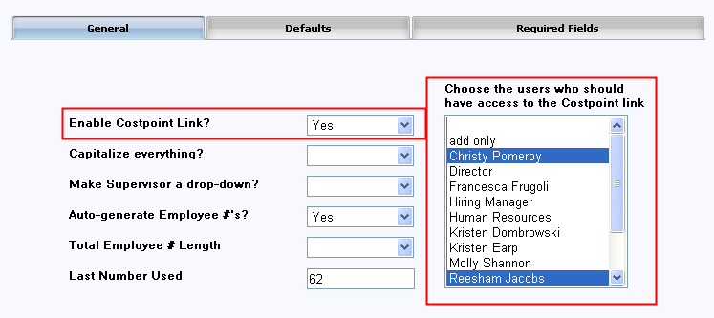

Question | Response | Result
Enable Costpoint Link? | Yes | All of Costpoint-specific pages and menu items will be added in Cyber Recruiter.
Enable Costpoint Link? | Yes | Additional Action Needed: Highlight the Users in the Drop-Down List who should have access to the Costpoint-specific functions in Cyber Recruiter. Hold the CRTL key down to select more than one User.
Enable Costpoint Link? | No | Users will not see any references to Costpoint in Cyber Recruiter.

Step 2: Building Code Tables
Once you have enabled the interface a menu item under Admin > Codes will be accessible. Move to this location to enter the necessary codes to complete the setup and to use the interface on a daily basis. All code tables must be populated with valid codes from the Deltek Costpoint system (they must match exactly). If your codes can be placed into a comma delimited file they can be imported into the system via Admin > Processes > Import Code Table. See appendix A for information on this option.

To manually enter codes, go to Admin > Codes > Costpoint

Set Prior to Completing “Defaults” in the setup page:

- Employee Class
- Leave Cycle
- Pay Type
- Timesheet Cycle
- Worker’s Comp

Set Prior to Using the Interface on a Daily Basis:

- Companies
- GLC
- Home Department
- Job Titles
- Labor Location
- Labor Group
- Locator
- Reasons
- Security Org ID
- Visa Type

Most of the codes in the setup section are independent of each other. However, three (3) codes build upon each other. It is best to populate these codes in the following order:
Workers Comp
Job Codes / Job Title
GLC Code (Labor Category)

Step 3: Setting Data Options
Move back to Admin > Links > Pre-Defined Links > Deltek Costpoint to complete the setup.

The Costpoint setup with Cyber Recruiter allows for the passing of HR information. There are system settings, defaults and code tables to be set.

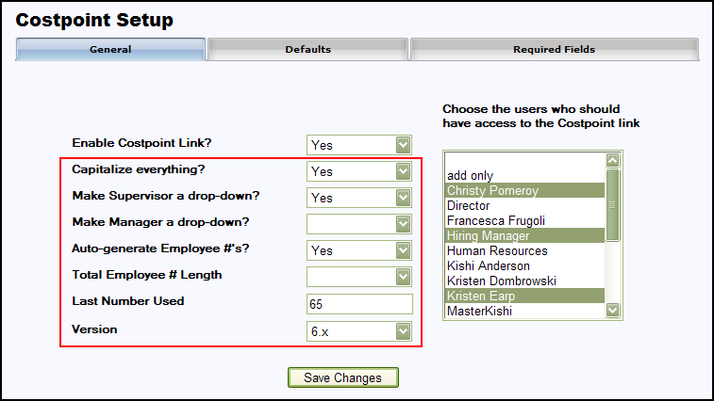

Question | Answer | Result / Detail
Capitalize everything? | Yes | All data transferred to Costpoint will appear in capitalized lettering. Some Costpoint users require this to make certain search functions work properly in Costpoint.
Capitalize everything? | No | All data transferred to Costpoint will appear as it was entered in Cyber Recruiter.
Make Supervisor a drop-down? | Yes | Supervisor field on each individual’s Costpoint page will be a drop-down field filled with Cyber Recruiter User IDs.
Make Supervisor a drop-down? | No | Supervisor field on each individual’s Costpoint page will be an open text box to enter a name.
Make Manager a drop-down? | Yes | Manager field on each individual’s Costpoint page will be a drop-down field filled with Cyber Recruiter User Names.
Make Manager a drop-down? | No | Manager field on each individual’s Costpoint page will be an open text box to enter a name.
Auto-Generate Employee #s | Yes | Cyber Recruiter will populate each new Costpoint export with the next available employee number.  Additional Action Needed: Enter the last number assigned as an employee number in the ‘Last Number Used’ field.
Auto-Generate Employee #s | No | User exporting new hires will manually enter each individual’s new ID number manually.
Total Employee # Length | 1 – 12 | Indicate the total length of the employee number (for example if it has to be exactly 6 characters)
Leading Characters |  | Enter any special characters which should be passed to Costpoint in front of the employee number. Putting ‘S’ would product the numbers S0009, S00010, etc.
Version | 5, 6, 6.1 | Select the version of CostPoint in use.

Step 4: Setting Costpoint Defaults
Enter field defaults as Users should see them when transferring Employees to Costpoint. The default value always overrides whatever is stored for any particular Individual. If no default is entered, it can be entered on the Applicant File > Costpoint Page.

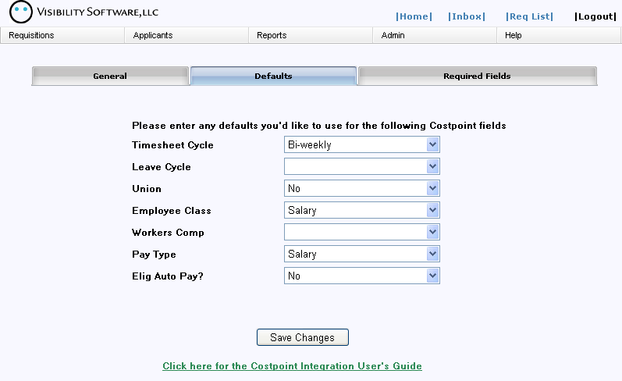

Step 5: Define Required Fields
The Required Fields Tab allows the Administrator to indicate which fields are required during the completion of the export process to Costpoint. If a field is checked on this page and a particular individual does not have that field populated when an export is run, that particular individual will not be exported and an error will appear on the export error log indicating that the person was missing a piece of required information.

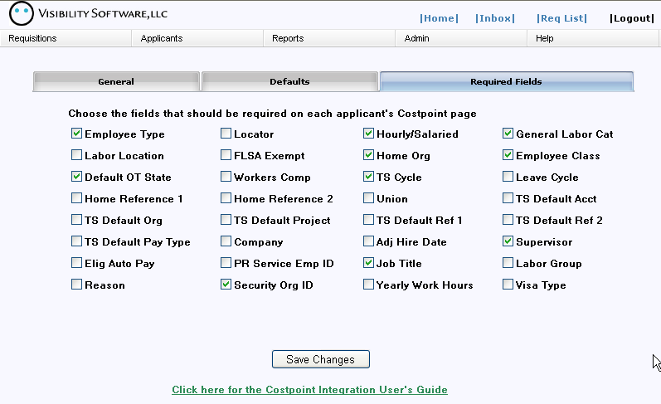

Daily Use – Transferring Applicants to Costpoint

Step 1: Prepare the individual & Verify Required Fields
Once the Costpoint interface is enabled a Costpoint Page in the Applicant File will appear for any users specified in the setup. This page will appear for all applicants but should only be complete for individuals who should be sent over to Costpoint. To start the process, find the individual’s record that will be exported to Costpoint.

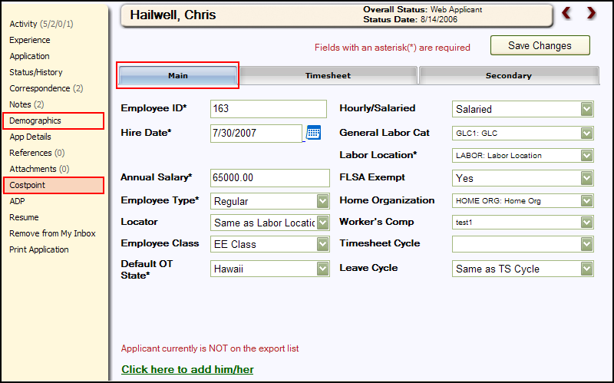

Once the Individual is located, there are six (6) fields required for the transfer to Costpoint, three (3) are on the Demographics Page and three (3) are on the Costpoint Page, available on the left-hand toolbar for users who have access to the Costpoint pages. If you are using this page in conjunction with the ‘New Hire Process’ you can activated the Demographics page to appear before this page to ensure total accuracy of information.

Demographics Page: First Name, Last Name, Country (defaults to US if blank)
Costpoint Page: Employee ID, Hire Date, Pay Rate

Step 2: Complete Costpoint Page
This page is necessary to transfer Individuals into Costpoint because it contains information that doesn’t already exist in Cyber Recruiter. The data from this page in addition to standard data that Cyber Recruiter stores (name, address, phone number, etc…) are transferred for new hires. Before transferring an individual from Cyber Recruiter to Costpoint, ensure this page is complete and contains all the required information for that Individual.

Main Tab – Basic information about the Individual such as pay and labor information. If the Administrator set up this page to assign Employee ID automatically, leave the field blank on this screen.

Timesheet Tab –Information regarding this Individual’s timesheet.

Secondary Tab – Information regarding this individual’s employment with the organization.

All User-Defined codes must be set in Admin > Codes prior to being used on this page. All fields set as required fields must be completed on this screen prior to export or the file will generate an error and this individual’s file will not be included in the export to Costpoint. Defaults will occur as the Administrator setup them to apply.

Step 3: Add Record to the Export File
Click on the green link at the bottom of the page to add this individual to the export file. The red indicator will change to indicate whether the individual is on the list of people to be exported. In this example, the link has not been clicked yet.

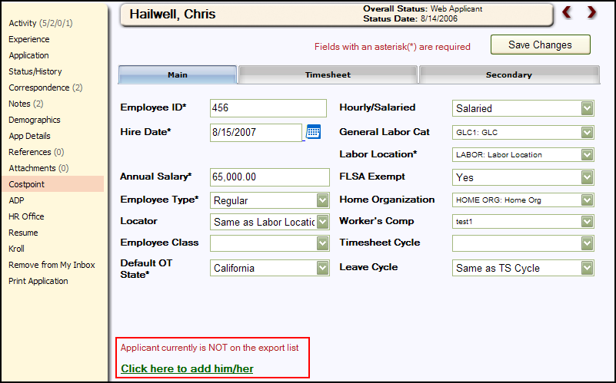

Step 4: Generate Export File
After verifying and adding the individual to the export file, from the main menu bar select Applicants > Costpoint Export to generate the export file.

If the Cyber Recruiter Administrator setup to automatically generate the Employee ID number, when the individual is added to the list, he/she will be assigned an ID number. This ID number will also show on the Applicant File (Employee File) > Costpoint Page. If the Employee ID number is not set up to automatically generate, the number at this point will pull from the Applicant File (Employee File) > Costpoint Page > Employee ID Field.

The table that displays lists the individuals who have been added to the export file via the Applicant File > Costpoint Page. To add additional records to the list, press the Add button and find the Individual. To remove records from the list, check the box at the end of the line and then click the Delete Selected button. Using the Select All or Deselect All links at the top will place checkmarks or remove check marks next to everyone’s record. Everyone listed here will be included in the export file.

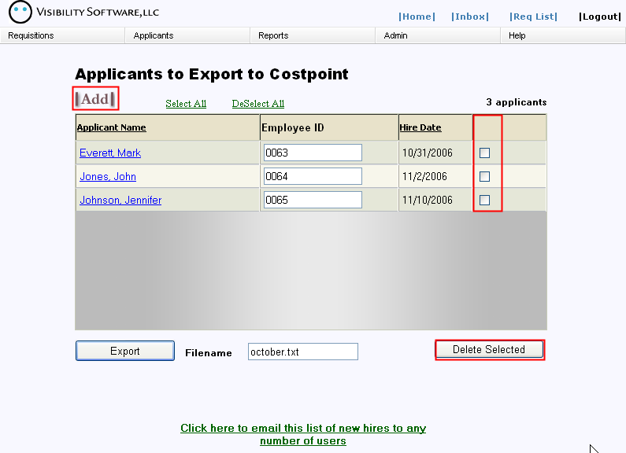

Enter the name of the file in the Filename field and click the Export button to create the export file. Cyber Recruiter will save the last export file created. However, this file will be overwritten each time the export process is run.

Step 5: Verify Results
The page which appears allows you to verify the results and eventually to save the file generated to a network or disk location.

correcting Errors
If the error log indicates that some individuals are missing information, the information for those records should be entered and another export performed. Click the Print link to print a report as needed t and click the Individual name to enter the file o make the necessary changes. Re-run the export process; the export process can be run as many times as needed to obtain an error free file.

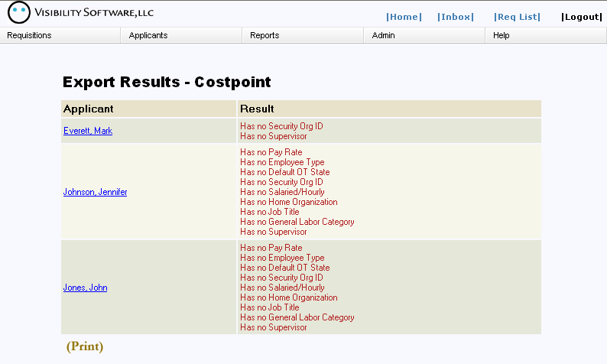

saving the file
If the error log indicates that all individuals were Exported Successfully, right-click the indicated link and choose Save Target As to download the ASCII text file created to the network or hard drive. Put the files in a folder on a PC that the Costpoint contact will have access to so that person can pull the file into Costpoint using the Employee Preprocessor. Click on the Return to Costpoint Export Page to finish the process.

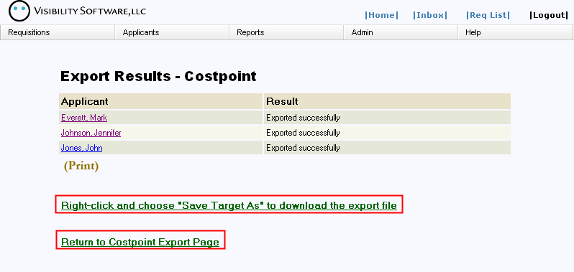

Step 6: Prepare Export List for Next Batch
To prepare the Costpoint Export page for the next batch of new hires, press the Select All link to place a checkmark next to the Applicant’s names. Then, press the Delete Selected button to remove them from this list.

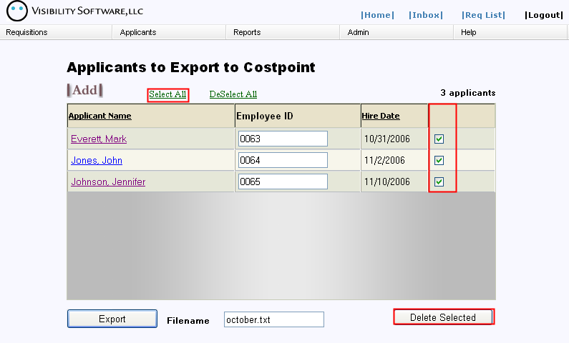

Step 7: Import into Costpoint
Using the Employee Preprocessor module of Costpoint, browse to the file generated by Cyber Recruiter. Import this file and verify the data for accuracy upon bringing the file into the system.

Data Mapping - Costpoint
This information is adapted from the Deltek Costpoint Employee Pre-Processor documentation. Please reference that manual for more detailed information on this connection piece between Cyber Recruiter and Costpoint.

Processing Details

Input Record 1
Field Name Data Type and Size Required/Optional Contents
Record Code Character 1 Required N or 1
Social Security Number Numeric 9 Required
Employee ID Character 12 Required
First Name Character 20 Required
Middle Name Character 10 Optional
Last Name Character 25 Required
Hire Date Character 10 Required YYYY-MM-DD
Employee Status Character 3 Default Provided ACT, FML, IAL, IN
Timesheet Cycle Character 4 Default Provided
Leave Cycle Character 4 Default Provided
General Labor Category Character 6 Default Provided
Pay Type Character 3 Default Provided
FLSA Exempt Character 1 Default Provided Y, N
Employee Type Character 1 Default Provided R, P
Hourly/Salaried Character 1 Default Provided H, F, S
Home Organization Character 20 Default Provided
Home Reference 1 Character 20 Optional
Home Reference 2 Character 20 Optional
Default OT State Character 2 Default Provided
Worker's Comp Character 6 Default Provided
Effective Date Character 10 Required YYYY-MM-DD
Rate Type Character 1 Default Provided A, H, S
Rate Numeric 14 Required
Account Character 15 Optional
Organization Character 20 Optional
Project Character 30 Optional
Reference 1 Character 20 Optional
Reference 2 Character 20 Optional
Labor Location Character 6 Optional
Address Line 1 Character 30 Optional
Address Line 2 Character 30 Optional
Address Line 3 Character 30 Optional
City Character 25 Optional
State Character 15 Optional
Country Character 8 Optional
Postal Code Character 10 Optional
Home Telephone Character 20 Optional
Emergency Telephone Character 20 Optional
Locator Character 6 Optional
Date Of Birth Character 10 Optional YYYY-MM-DD
Marital Status Character 1 Optional
Gender Character 1 Optional M, F
Employee Class Character 12 Optional
Union Employee Flag Character 1 Required Y, N

Input Record 2
Field Name Data Type and Size Required/Optional Contents
Record Code Character 1 Required 2
Employee ID Character 12 Required
Company Character 10 Default Provided
Adjusted Hire Date Character 10 Optional YYYY-MM-DD
Termination Date Character 10 Optional YYYY-MM-DD
Supervisor Name Character 25 Optional
Preferred Name Character 10 Optional
Name Prefix Character 6 Optional
Name Suffix Character 6 Optional
Prior Name Character 25 Optional
Eligible for Auto Pay Character 1 Default Provided Y, N
Email ID Character 20 Optional
PR Service Employee ID Character 12 Optional
Job Title Description Character 30 Optional
Estimated Hours Numeric 10 Optional
Labor Group Character 3 Optional
Reason Character 30 Optional
Security Organization ID Character 20 Default Provided
Work Hours in Year Character 4 Default Provided
Visa Type Character 10 Optional Check Costpoint for values
Comments Character 254 Default Provided

Deltek Vision –Dynamic link

Establishing Connectivity
The process for transferring new hires from Cyber Recruiter to Deltek vision using the dynamic requires knowledge of the SQL information to connect to the Vision database. Once you have obtain this information, move to the setup regarding setting up the Admin section in Cyber Recruiter.

Admin Setup – Enabling Deltek Vision

Step 1: Setting Global Defaults
Admin > Links > Pre Defined Links > Deltek Vision

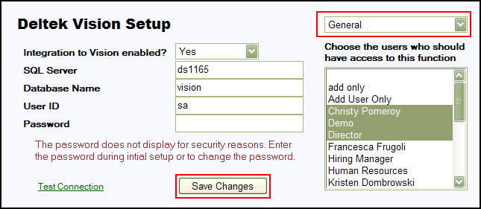

Question | Response | Result
Integration to Vision enabled? | Yes | All of Vision-specific pages and menu items will be added in Cyber Recruiter.
Integration to Vision enabled? | Yes | Additional Action Needed: Highlight the Users in the Drop-Down List who should have access to the Vision-specific functions in Cyber Recruiter. Hold the CRTL key down to select more than one User.
Integration to Vision enabled? | No | Users will not see any references to Vision in Cyber Recruiter.
SQL Server | Open Text | SQL Server where Deltek Vision is located
Database Name | Open Text | Deltek Vision’s database name
User ID | Open Text | SQL Login ID to Visions
Password | Open Text | SQL Password to Visions

Once the information is set on the General page, change the page to Required Fields. Highlight the fields on this page which should be required prior to transferring information to Vision.

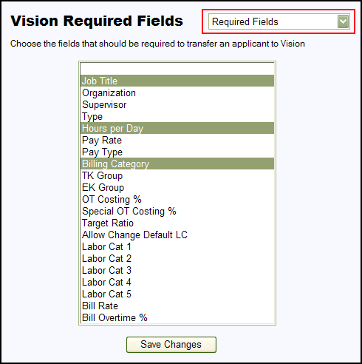

Once the information is set on the Required Fields page is complete use the drop-down list to change the page to Custom Fields. Identify any fields currently in Cyber Recruiter which can be passed to Vision’s custom fields. Use the drop-down menus to identify the location of the information in Cyber Recruiter.

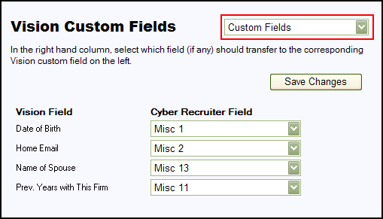

Daily Use – Transferring Applicants to Deltek Vision
The transfer process (Cyber Recruiter to Deltek Vision) replaces the New Hire Action in Deltek. When an applicant needs to be ‘hired’ into Deltek, this is done one at a time from the Applicants > Hire into Deltek Vision process in Cyber Recruiter.

Step 1: Find the Applicant
If you are using the option to ‘Process New Hire’ you can skip this step as the system will already know which individual you are working with.

From the Applicant’s menu, select Hire into Vision. Find the desired individual to move into Vision by identifying the individual via his/her Last Name, Email, Applicant ID #, Overall Status or Range (Application Date).

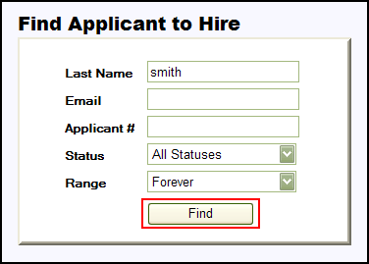

Find the desired Applicant that needs to be transferred to Vision. Identify the applicant via his/her Last Name, Email, Applicant ID #, Overall Status or Range (Application Date).

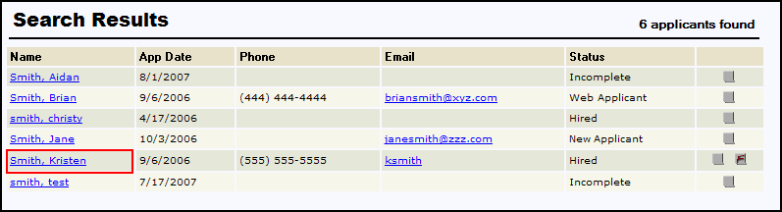

Once the Applicant is found, select the Applicant by clicking on the blue hyperlink Applicant Name.

Step 2: Enter Employee Identifiers

Enter the Employee Number (unique identifier for Deltek) and the Hire Date for this employee.

Step 3: VERIFY Information
Make any necessary changes to the demographics information that has been captured by Cyber Recruiter. First Name and Last Name are required fields on this page.

Remember that the email address that is being passed over to Vision should be the new corporate email address if emailing from Vision is an organizational practice.

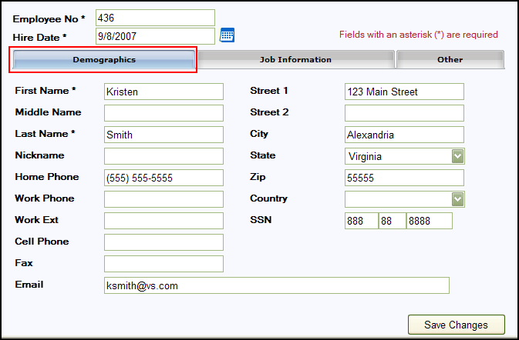

Enter the necessary job related information in the fields provided. Some of these fields might be required as determined by the Administrator.

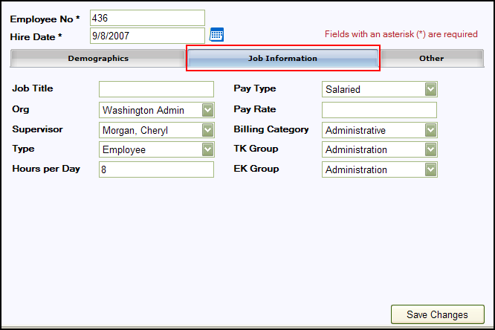

Enter the necessary other information in the fields provided. Some of these fields might be required as determined by the Administrator.

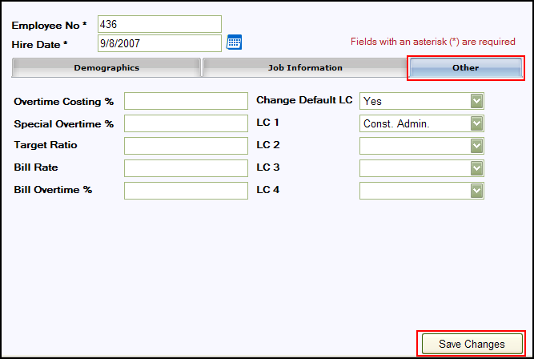

Where the Data Goes

In addition to the following information, skills and education are also added to the appropriate tables/views in Vision.

** This information was adapted from the Deltek Vision specification document ***

Vision Field Name | Cyber Recruiter Field Name
Employee | Employee ID from Applicant File > Vision Page
Lastname | Last name
Firstname | First name
Middlename | Middle name
Payrate | Pay Rate from Applicant File > Vision Page
Jobcostrate | Pay Rate from Applicant File > Vision Page
Jobcosttype | Pay Type from Applicant File > Vision Page
Paytype | Pay Type from Applicant File > Vision Page
Payovtpct | Overtime Costing % from Applicant File > Vision Page
Jcovtpct | Overtime Costing % from Applicant File > Vision Page
Targetratio | Target ratio from Applicant File > Vision Page
Hoursperday | Hours per Day from Applicant File > Vision Page
Hiredate | Hire Date from Applicant File > Vision Page
Status | “A”
Type | Type from Applicant File > Vision Page
Org | Org from Applicant File > Vision Page
Billingcatergory | Billing Category from Applicant File > Vision Page
Billingpool | 0
SSN | SSN
Address1 | Home Address 1
Address2 | Home Address 2
City | Home City
State | Home State
Zip | Home Zip
Country | Home Country
Homephone | Home Phone
Fax | Fax
Email | Email
Tkgroup | TK Group from Applicant File > Vision Page
Tkadminedit | “N”
Tkadminapproval | “N”
Ekgroup | EK Group from Applicant File > Vision Page
Ekadminedit | “N”
Ekadminapproval | “N”
Provcostrate | Pay Rate from Applicant File > Vision Page
Provbillrate | Bill Rate from Applicant File > Vision Page
ProvCostotpct | Overtime Costing % from Applicant File > Vision Page
Provbillotpct | Billing Costing % from Applicant File > Vision Page
Changedefaultlc | Changed Default LC from Applicant File > Vision Page
Defaultlc1 | LC1 from Applicant File > Vision Page
Defaultlc2 | LC2 from Applicant File > Vision Page
Defaultlc3 | LC3 from Applicant File > Vision Page
Defaultlc4 | LC4 from Applicant File > Vision Page
Defaultlc5 | LC5 from Applicant File > Vision Page
UseTotalHrsAsStd | “N”
ProvCostSpecialOTPct | Overtime Costing % from Applicant File > Vision Page
ProvBillSpecialOTPct | 0
Title | Job Title from Applicant File > Vision Page
YearsOtherFirms | 0
Exportlnd | “N”
Consultantlnd | “N”
Supervisor | Supervisor from Applicant File > Vision Page
Workphone | Work Phone
Workphonext | Work Extension
Mobilephone | Cell Phone
Createuser | “CR”
Createdate | Current Date
AvailableForCRM | “Y”
ReadyForApproval | “Y”
ReadyForProcessing | “Y”
Moduser | “CR”
Moddate | Current Date
LocaleMethod | 0
Otherpay | 0
Otherpay2 | 0
Otherpay3 | 0
Otherpay4 | 0
Otherpay5 | 0
CostRateMeth | 0
CostRateTableNo | 0
PayRateMeth | 0
UtilizationRatio | 0
PriorYearsFirm | 0
IncludeLocalJurisOnly | “N”
Payspecialovtpct | Special Overtime % from Applicant File > Vision Page
Jcspecialovtpct | Special Overtime % from Applicant File > Vision Page
PreferredName | Nickname

GCS Premier –File Export

Admin Setup – Enabling GCS Premier HR
The process for transferring new hires from Cyber Recruiter to the GCS Premier product involves exporting the information to an ASCII Text file and importing that file into GCS Premier via its Employee Preprocessor utility. Cyber Recruiter automates this task by creating the file from within Cyber Recruiter itself.

Step 1: Setting Global Defaults
Admin > Links > Pre Defined Links > GCS Premier

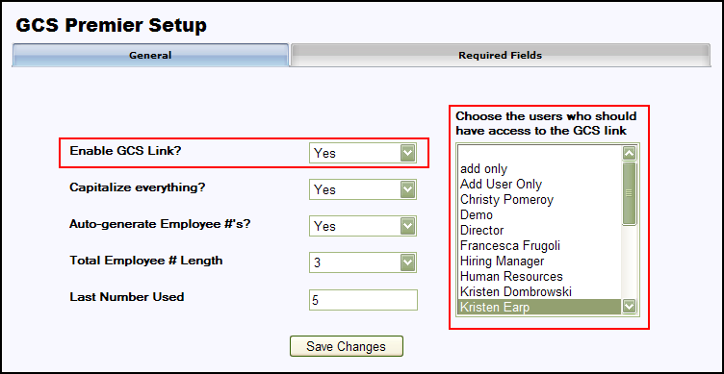

Question | Response | Result
Enable GCS Premier Link? | Yes | All of GCS Premier-specific pages and menu items will be added in Cyber Recruiter.
Enable GCS Premier Link? | Yes | Additional Action Needed: Highlight the Users in the Drop-Down List who should have access to the GCS Premier-specific functions in Cyber Recruiter. Hold the CRTL key down to select more than one User.
Enable GCS Premier Link? | No | Users will not see any references to GCS Premier in Cyber Recruiter.
Capitalize everything? | Yes | All data transferred to GCS Premier will appear in capitalized lettering. Some GCS Premier Users require this to make certain search functions work properly in GCS Premier.
Capitalize everything? | No | All data transferred to GCS Premier will appear as it was entered in Cyber Recruiter.
Auto-Generate Employee #s | Yes | Cyber Recruiter will populate each new GCS Premier export with the next available employee number.  Additional Action Needed: Enter the last number assigned as an employee number so the system can assign then next employee number.
Auto-Generate Employee #s | No | User exporting new hires will manually enter each applicant’s new ID number manually.
Total Employee # Length | 1 – 12 | Indicate the total length of the employee number (for example if it has to be exactly 6 characters)

Step 2: Verifying Code Tables
To accomplish this step, the Administrator needs verify the GCS Premier code tables are up-to-date in Admin > Codes > GCS Premier as some of the default depend on this these code table.

- Division
- Department
- OBS Number
- Employee Type
- Rate Type
- Pay Frequency
- Labor Category
- Fed Filing Status
- State Filing Status

All code tables must be populated with valid codes from the GCS Premier system. Alternatively, codes can be imported from an ASCII text file of codes directly into Cyber Recruiter’s code tables under Admin > Processes > Import Code Table. See the Cyber Recruiter Admin Guide for more information on this process.

step 3: Define Required Fields
The Required Fields Tab allows the Administrator to indicate which fields are required during the completion of the export process to GCS Premier. If a field is checked on this page and a particular applicant does not have that field populated when an export is run, that particular applicant will not be exported and an error will appear on the export error log indicating that the person was missing a piece of required information.

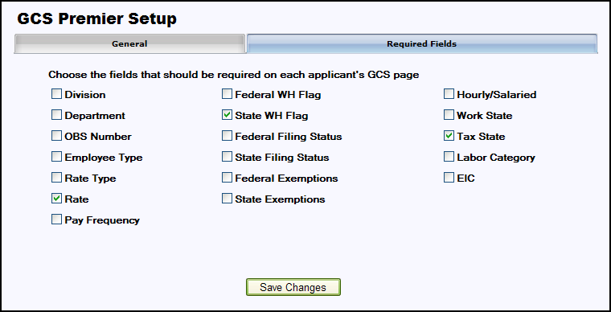

Daily Use – Transferring Applicants to GCS Premier
The transfer process (Cyber Recruiter to GCS Premier) is done one at a time from the Applicants > GCS Premier Export process in Cyber Recruiter.

Step 1: Prepare the Applicant & Complete Required Fields
This page is necessary to transfer Applicants into GCS Premier because it contains information that doesn’t already exist in Cyber Recruiter. The data from this page in addition to standard data that Cyber Recruiter stores are transferred for new hires. Before transferring an applicant from Cyber Recruiter to GCS Premier, ensure that this page is complete and contains all the required information for that Applicant.

Find the Applicant to export - Applicants > Find Applicant. Once the Applicant is located enter the necessary information as needed in the Main Tab and the Tax Info Tab.

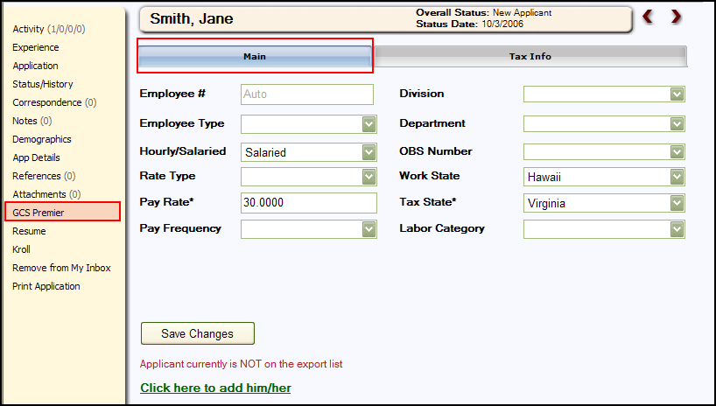

All User-Defined codes must be set in Admin > Codes prior to being used on this page. All fields set as required fields must be completed on this screen prior to export or the file will generate an error and this Applicant/ Employee File will not be included in the export to GCS Premier. Defaults will occur as the Administrator setup them to apply.

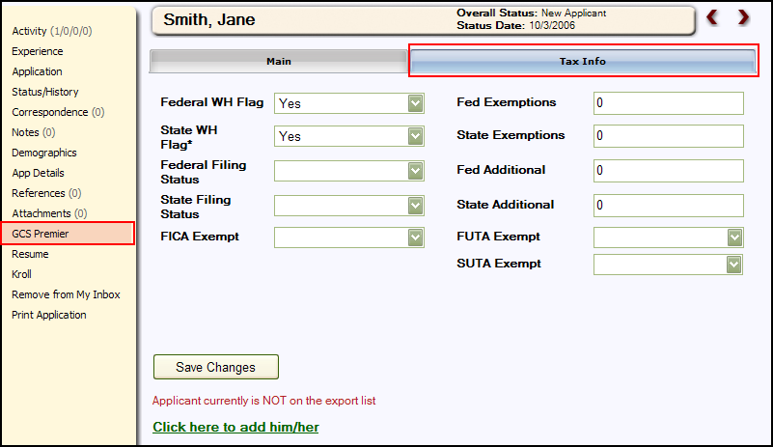

Step 2: Add Record to the Export File
Click on the green link at the bottom of the page to add this Applicant to the export file. The red indicator will change to indicate whether the applicant is on the list of applicants to be exported. In this example, the link has been clicked.
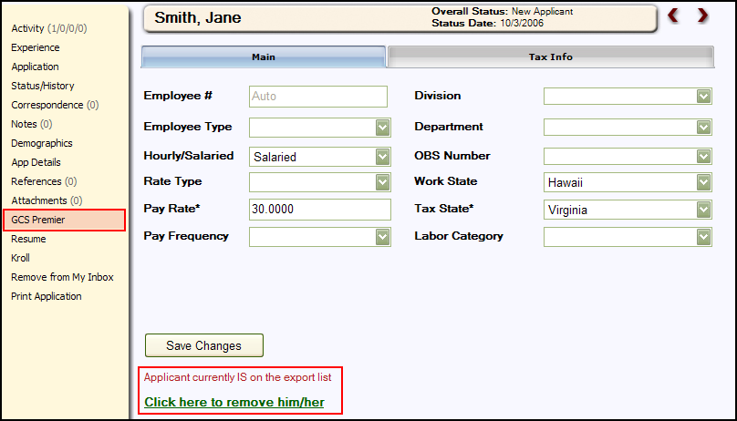

Step 3: Generate Export File
After verifying and adding the Applicant to the export file, from the main menu bar select Applicants > GCS Premier Export to generate the export file.

If the Cyber Recruiter Administrator setup to automatically generate the Employee ID number, when the Applicant is added to the list, he/she will be assigned an ID number. This ID number will be grayed out and say ‘Auto’ on the Applicant File (Employee File) > GCS Premier Page. If the Employee ID number is not set up to automatically generate, the number at this point will pull from the Applicant File (Employee File) > GCS Premier Page > Employee ID Field.

This table displays the Applicants who have been added to the export file via the Applicant File > GCS Premier Page. To add additional applicant to the list, press the Add button and find the Individual. To remove Applicants from the list, check the box at the end of the Individual name click the Delete Selected button. Using the Select All or Deselect All links at the top will place checkmarks or remove check marks next to everyone’s record. Everyone listed here will be included in the export file.

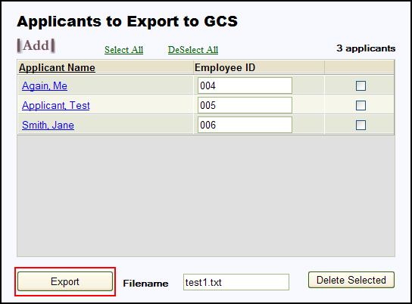

Click the Export button to create the export file. Enter the name of the file in the Filename field. Cyber Recruiter will save the last export file created. However, this file will be overwritten each time the export process is run.

Step 4: VERIFY Results

Corrections Needed
This page lists any errors that occurred during the export process. If the error log indicates that some employees are missing information, the information for those employees should be entered and another export performed. Click the Print link to print a report as needed t and click the Individual name to enter the file o make the necessary changes. Re-run the export process; the export process can be run as many times as needed to obtain an error free file.

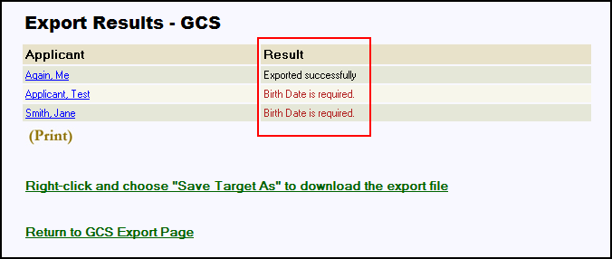

saving the file
If the error log indicates that all individuals were Exported Successfully, right-click the indicated link and choose Save Target As to download the ASCII text file created to the network or hard drive. This file is then imported into GCS Premier using the preprocessor. Click on the Return to GCS Export Page to finish the process.

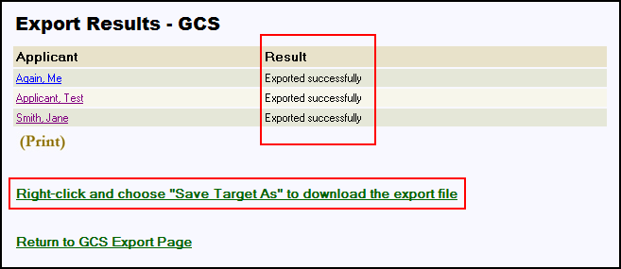

Step 5: Prepare Export List for Next Batch
To prepare the GCS Export page for the next batch of new hires, press the Select All link to place a checkmark next to the Applicant’s names. Then, press the Delete Selected button to remove them from this list.

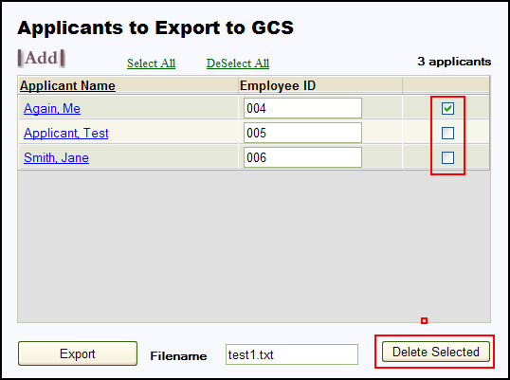

Step 6: Import into GCS premier
Using the Employee Preprocessor module of GCS Premier, browse to the file generated by Cyber Recruiter. Import this file and verify the data for accuracy upon bringing the file into the system.

Data Mapping

** This information was adapted from the Deltek GCS Premier Specification document ***This program will update existing records and add new records, but will not delete records. "Deletes" must be performed manually through the Deltek GCS Premier program. The Input Data file should contain new employees and employees with changes, but may contain all employees if desired.

All input will be validated as follows:

Field | Defaults | Validations
Employee ID | None | Must be unique.
Division Number | 01 | Must be numeric. Must be less than or equal to number of divisions set up in the General Ledger Control File.
Department Number | 00 | Must be in Deltek GCS Premier's Department/Transaction Code File.
Last Name, First Name & Middle Initial | None | Must be unique in the Deltek GCS Premier Employee Master File. New employees must have both a First and Last Name.
OBS Number | Zeros | If OBS numbers are used, must be in proper format  (XX.XX.XX.XX.XX.XX). They must also exist in the Deltek GCS Premier.
Social Security Number | None | Must be in format 999-99-9999. Required for new employees.
Sex | None | Must be Male or Female. May be blank for consultants.
Marital Status | None | Must be Single, Married, Divorced or Widowed. May be blank for consultants.
Status | A | Must be Active or Inactive.
Employee Type | R | Must be Regular, Part Time or Consultant.
Exempt | None | Must be Yes or No.
Rate Type (Single record format only) | None | Must be Annual, Salaried, or Hourly.
Rate | None | Must be numeric.
Pay Frequency | None | Must be Weekly, Bi-Weekly, Semi-Monthly or Monthly. May be blank for consultants.
Working State | None | Must exist in the Deltek GCS Premier State Name Table (uses Postal abbreviations). May be blank for consultants.
Default Suffix | 39 | Must be 00, 39, 40, 41, or 42.
Hourly or Salaried Flag | None | Must be Hourly or Salaried. May be blank for consultants
Labor Category | None | Must exist in the Deltek GCS Premier Job Category Table. May be blank for consultants.
Earned Income Credit Flag | N | Must be Full, Half, Single or No
Federal Withholding Flag | Y | Must be Yes or No. N for consultants.
Federal Filing Status | None | Must be Single or Married. Required if Federal Withholding Flag = Y
State Filing Status | None | Must be Single, Married, 1, 2, 3, 4. Required if State Withholding Flag = Y
Number of Federal Exemptions | Zero | Must be numeric.
Number of State Exemptions | Zero | Must be numeric.
Additional Federal Withholding | Zero | Must be numeric.
Additional State Withholdings | Zero | Must be numeric.
Taxing State | Working State | Must exist in Deltek GCS Premier’s State Name Table (use Postal abbreviations). May be blank for consultants.
FICA Exempt Flag | N for Regular or Part-Time Employees. Y for consultants | Must be Yes or No.
FUTA Exempt Flag | N for Regular or Part-Time Employees. Y for consultants | Must be Yes or No.
SUTA Exempt Flag | N for Regular or Part-Time Employees. Y for consultants | Must be Yes or No.
Date of Birth | Zeros | Must be a valid date or zeros. Must be in the YYYYMMDD format.
Street | None | None
Street Line 2 | None | None
City | None | None
State | None | None
Zip Code (first five) | None | None
Zip Code (last four) | None | None
High Compensation Flag | L | Must be High, Low, or Ineligible
Key Employee Flag | N | Must be Yes or No

Great Plains –File Export

Admin Setup – Enabling Great Plains
The process for transferring new hires from Cyber Recruiter to the Great Plains product involves exporting the information to an ASCII Text file and importing that file into Great Plains. Cyber Recruiter automates this task by creating the file from within Cyber Recruiter itself.

Step 1: Setting Global Defaults
Admin > Links> Pre Defined Links > Great Plains
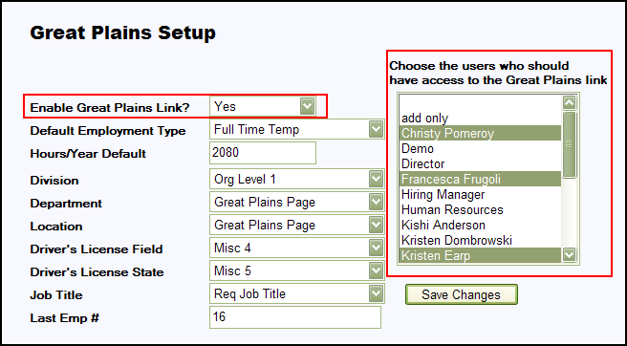

Question | Response | Result
Enable Great Plains Link? | Yes | All of Great Plains-specific pages and menu items will be added in Cyber Recruiter.
Enable Great Plains Link? | Yes | Additional Action Needed: Highlight the Users in the Drop-Down List who should have access to the Great Plains-specific functions in Cyber Recruiter. Hold the CRTL key down to select more than one User.
Enable Great Plains Link? | No | Users will not see any references to Great Plains in Cyber Recruiter.
Default Employment Type? | Hard Coded Table | Value entered here will default in when transferring New Hires into the Great Plains product.
Hours/Year Default | Open Text Field | Value entered here will default in when transferring New Hires into the Great Plains product.
Division | Code Table | Division field on each Applicant’s Great Plains Page will be a drop-down field.
Department | Code Table | Department field on each Applicant’s Great Plains Page will be a drop-down field.
Location | Code Table | Location field on each Applicant’s Great Plains Page will be a drop-down field.
Driver’s License Field | Misc Field or Open Text | Pulls the License number from a pre-determined misc field or it is an open text on the Great Plains Page
Driver’s License State | Misc Field or Open Text | Pulls the License number from a pre-determined misc field or it is an open text on the Great Plains Page
Job Title | Req Job Title or Open Text | Pulls the Requisition Job Title from the Main Page or it is an open text field on the Great Plains Page
Last Emp # | Open Text Field | Stores the last Great Plains employee number assigned to Applicants exported from Cyber Recruiter. Reset as necessary.

Step 2: Verifying Code Tables
To accomplish this step, the Administrator needs verify the Great Plains tables are up-to-date in Admin > Codes > Great Plains.

All of these code tables are required for transferring data to Great Plains. You only need to populate the Employment Classes, Divisions, Departments, Locations, Job Titles, and Supervisor Codes. Set these tables up as they are set up in Great Plains.

Daily Use – Transferring Applicants to Great Plains
The transfer process (Cyber Recruiter to Great Plains) is done one at a time from the Applicants > Great Plains Export process in Cyber Recruiter.

Step 1: Prepare the Applicant & Verify Required Fields
Once the Great Plains is enabled, a Great Plains Page in the Applicant File will default.

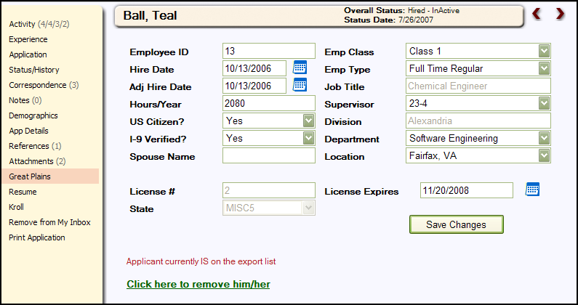

Find the Applicant to export - Applicants > Find Applicant. Once the Applicant is located, use the Great Plains Page to enter data that does not already exist in the Cyber Recruiter product. This information will be transferred in addition to the required pieces of information necessary for the transfer. Before transferring an Individual from Cyber Recruiter to Great Plains, ensure that this page is complete and contains all the required information for that applicant.

Step 2: Add Record to the Export File
Click on the green link at the bottom of the page to add this Applicant to the export file. The red indicator will change to indicate whether the applicant is on the list of applicants to be exported. In this example, the link has been clicked.

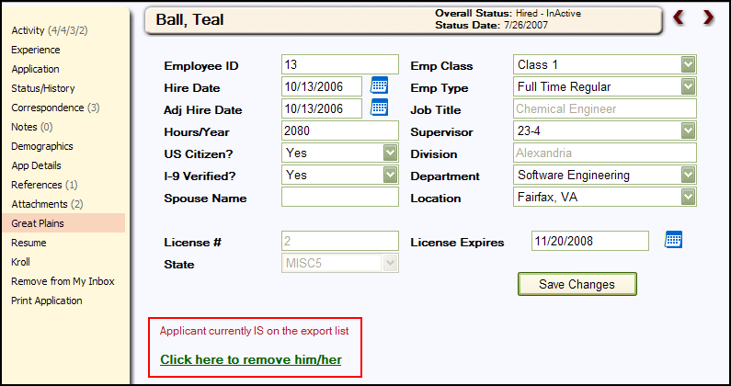

Step 3: Generate Export File
After verifying and adding the individual to the export file, from the main menu bar select Applicants > Great Plains Export to generate the export file.

The Employee ID number is pulled from the Applicant File (Employee File) > Great Plains Page > Employee ID Field.

The table which appears displays the Applicants who have been added to the export file via the Applicant File > Great Plains Page. To add additional applicant to the list, press the Add button and find the Individual. To remove Applicants from the list, check the box at the end of the Individual name click the Delete Selected button. Using the Select All or Deselect All links at the top will place checkmarks or remove check marks next to everyone’s record. Everyone listed here will be included in the export file.

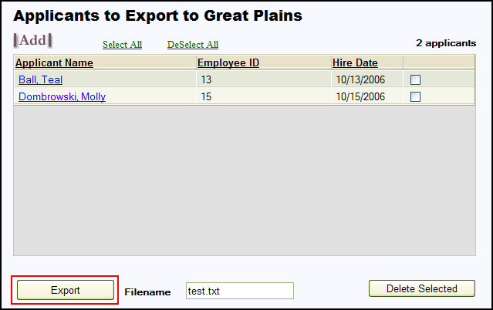

Step 4: Verify Results
Click the Export button to create the export file. Enter the name of the file in the Filename field. Cyber Recruiter will save the last export file created. However, this file will be overwritten each time the export process is run.

Make Corrections
Using the page which appears, verify no errors occurred. If the error log indicates that some records are missing information, the information for those individuals should be entered and another export performed. Click the Print link to print a report as needed to and click the Individual name to enter the file to make the necessary changes. Re-run the export process; the export process can be run as many times as needed to obtain an error free file.

Save file
If the error log indicates that all Applicants/Employees were Exported Successfully, right-click the indicated link and choose Save Target As to download the ASCII text file created to the network or hard drive. This file is then imported into Great Plains as necessary. Click on the Return to Great Plains Export Page to finish the process.

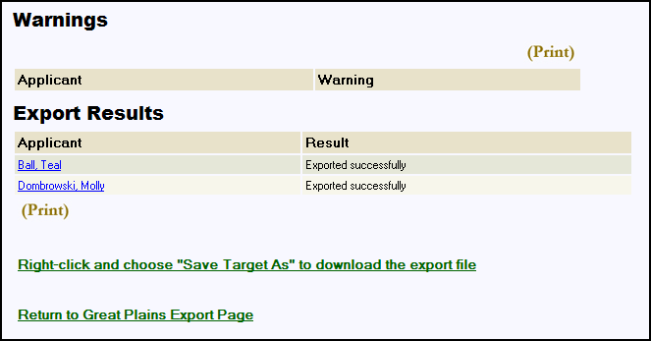

Step 5: Prepare Export List for Next Batch
To prepare the Great Plains Export page for the next batch of new hires, press the Select All link to place a checkmark next to the individual’s names. Then, press the Delete Selected button to remove them from this list.

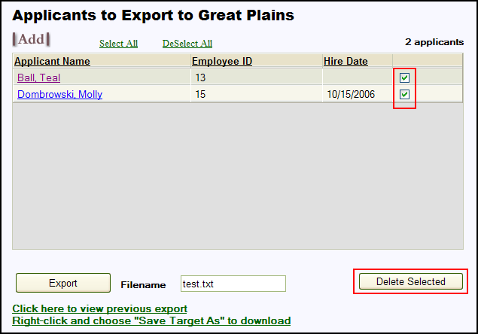

Step 6: Import into great Plains
Using the tools available via Great Plains, browse to the file generated by Cyber Recruiter. Import this file and verify the data for accuracy upon bringing the file into the system.

Data Mapping
The table below lists each of the field exported from Cyber Recruiter into the .csv file created.

Field | Notes
Employee ID | As entered on applicant’s Great Plains page.
Employee Class | As entered on applicant’s Great Plains page. Code entered under Admin/Codes/Great Plains
Last Name
First Name
Middle Name
“PRIMARY” | Address Code, always hard-coded as PRIMARY
SSN | SSN without dashes
Birth Date
Gender | 1-Male, 2-Female, 3-N/A
Ethnic Origin | 1- White, 2 - American Indian or Alaska Native, 3- Black, 4 - Asian or Pacific Islander, 5- Hispanic, 6 - Other, 7 - N/A
Marital Status | 1- Married, 2- Single, 3- N/A
Spouse Name | As entered on applicant’s Great Plains page.
Hire Date | As entered on applicant’s Great Plains page.
Adjusted Hire Date | As entered on applicant’s Great Plains page.
Employment Type | As entered on applicant’s Great Plains page. Code entered under Admin/Codes/Great Plains
Division | As entered on applicant’s Great Plains page OR pulled from a requisition field for the applicants HIRED req. Code entered under Admin/Codes/Great Plains
Department | As entered on applicant’s Great Plains page OR pulled from a requisition field for the applicants HIRED req. Code entered under Admin/Codes/Great Plains
Job Title | As entered on applicant’s Great Plains page OR pulled from a requisition field for the applicants HIRED req. Code entered under Admin/Codes/Great Plains
Location | As entered on applicant’s Great Plains page OR pulled from a requisition field for the applicants HIRED req. Code entered under Admin/Codes/Great Plains
Is Veteran? | Equals 1 if applicants is a disabled vet, Vietnam vet, or other vet
Home Street 1
Home Street 2
Home City
Home State
Home Zip
Home Country | Defaults to USA if empty
Home Phone | All numbers, no punctuation
Work Phone | All numbers, no punctuation
Cell Phone | All numbers, no punctuation
Hours/Year | As entered on applicant’s Great Plains page.
Email
Citizen | As entered on applicant’s Great Plains page.
I-9 Verified | As entered on applicant’s Great Plains page.
Disabled?
Disabled Vet?
Vietnam Vet?
Other Eligible Vet?
Education | Top 3 education records for applicant, each has school, degree, major, GPA, and graduation year
Driver’s License Info | State, a space, then Driver’s License #
Driver’s License Exp Date | Driver’s License Exp date as entered on applicant’s Great Plains page.

HR Office – File Export

Admin Setup – Enabling HR Office HR System
The process for transferring new hires from Cyber Recruiter to the HR Office product involves exporting the information to an XML file and importing that file into HR Office. Cyber Recruiter automates this task by creating the file from within Cyber Recruiter itself. It requires no extra software or work outside of the HR Office pages within Cyber Recruiter. HR Office enabled in Admin > Links > Pre-Defined > HR Office

Step 1: Setting Global Defaults
Admin > Links > Pre-Defined Links > HR Office

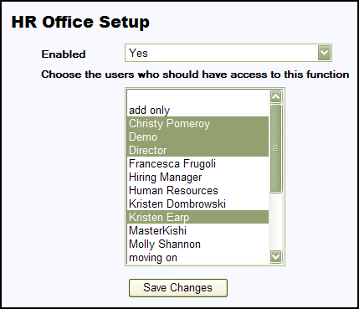

Question | Response | Result
Enabled? | Yes | All of HR Office-specific pages and menu items will be added in Cyber Recruiter.
Enabled? | Yes | Additional Action Needed: Highlight the Users in the Drop-Down List who should have access to the HR Office-specific functions in Cyber Recruiter. Hold the CRTL key down to select more than one User.
Enabled? | No | Users will not see any references to HR Office in Cyber Recruiter.

Step 2: Verifying Code Tables
To accomplish this step, the Administrator needs verify the HR Office code tables are up-to-date in Admin > Codes > HR Office. The six (6) code tables: Companies, Employment Status, Location, Division, Department, & Veteran Status. Only the Companies code table is required, but they are all recommended.

Daily Use – Transferring Applicants to HR Office

Step 1: Prepare the Applicant & Verify Required Fields
Once the HR Office setup is enabled, a HR Office Page in the Applicant File will default.

Find the Applicant to export - Applicants > Find Applicant. Once the Applicant is located, use the HR Office Page to enter data that does not already exist in the Cyber Recruiter product.

There are only two (2) fields required on this page: Company and Country. However, Employee #, Hire Date, and Employment Status, are typically required for any HR product. Fill out the fields on this page as needed and click the Save Changes button when finished. If the Company field is not filled in, Users will not be able to Save Changes

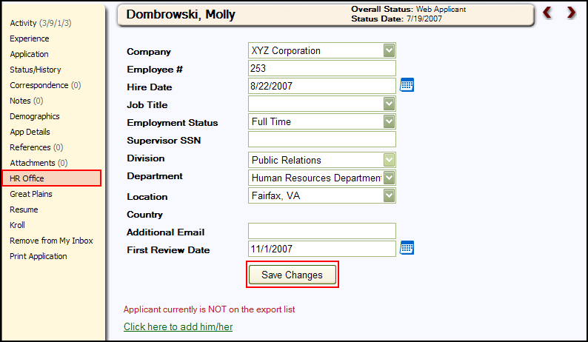

Step 2: Add Record to the Export File
Click on the green link at the bottom of the page to add this Applicant to the export file. The red indicator will change to indicate whether the applicant is on the list of applicants to be exported. In this example, the link has been clicked.

NOTE: Once the Applicant is on the export list, if the Applicant does not have the read-only Country field filled in, a warning message at the bottom of the page. The Country field pulls from the Applicant File > Demographics Page. Thus, Users will need to go back to the Demographics Page to fill this field in before attempting the export.

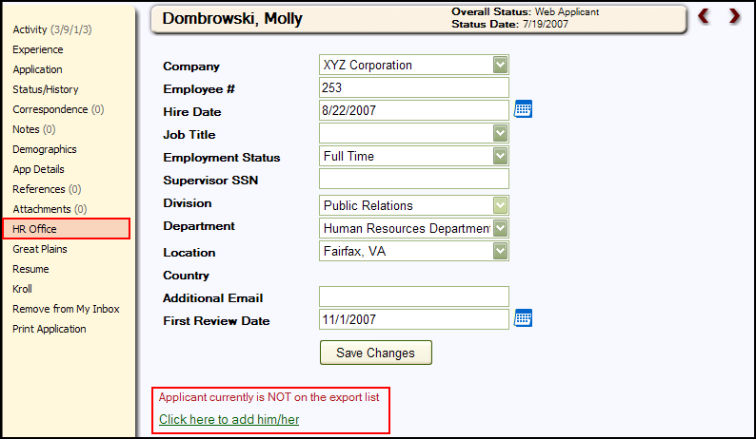

Step 3: Generate Export File
After verifying and adding the Applicant to the export file, from the main menu bar select Applicants > HR Office Export to generate the export file.

The Employee ID number is pulled from the Applicant File (Employee File) > HR Office Page > Employee # Field.

This table displays the Applicants who have been added to the export file via the Applicant File > HR Office Page. To add additional Applicants to the list, press the Add button and find the Individual. To remove Applicants from the list, check the box at the end of the Individual name click the Delete Selected button. Using the Select All or Deselect All links at the top will place checkmarks or remove check marks next to everyone’s record. Everyone listed here will be included in the export file.

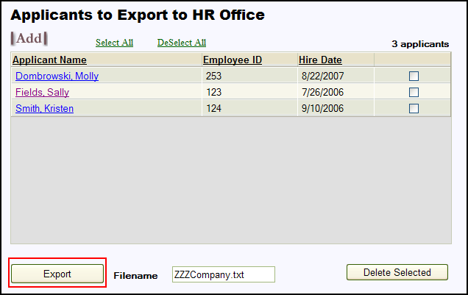

Click the Export button to create the export file. Enter the name of the file in the Filename field. Cyber Recruiter will save the last export file created. However, this file will be overwritten each time the export process is run.

Step 4: Verify Results

Make corrections
This page which appears will list any errors which occurred during the export process. If the error log indicates that some employees are missing information, the information for those employees should be entered and another export performed. Click the Print link to print a report as needed t and click the Individual name to enter the file o make the necessary changes. Re-run the export process; the export process can be run as many times as needed to obtain an error free file.

Retreiving the file
The XML file will be emailed to the user who generated it via Cyber Recruiter. Only records which were error free will be included in the file. To import the file, the user should save it to his/her hard drive or forward it to the staff member who will import it into HR Office. Click on the Return to HR Office Export Page to finish the process.

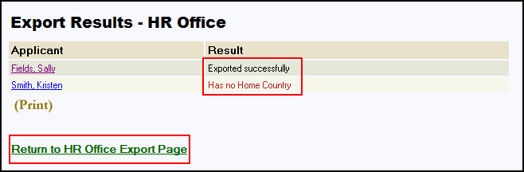

Step 5: Prepare Export List for Next Batch
To prepare the HR Office Export page for the next batch of new hires, press the Select All link to place a checkmark next to the Applicant’s names. Then, press the Delete Selected button to remove them from this list.

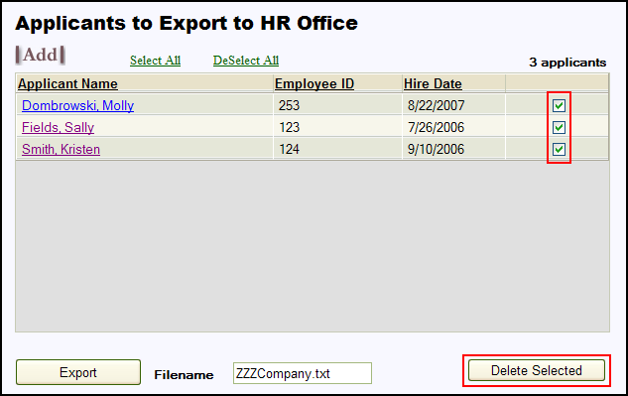

Step 6: Import into HR Office
Using the tools available via HR Office, browse to the file generated by Cyber Recruiter. Import this file and verify the data for accuracy upon bringing the file into the system.

Data Mapping
This information has been adapted from the HR Office specifications document.

The following is a list of the fields that are required to create new employee records within HROffice:
- Social Security or Canadian Social Insurance Number must be numeric and include 9 numbers. If dashes are entered the program will recognize it as a SSN or SIN number. (123-123-123 for a SIN or 123-12-1234 for a SSN). If there are no dashes the number will be treated as an Other ID.
- Full Alternative to Last Name and First Name. Full Name combines the employee’s full name into one field in the form of "Last, First, Middle" or "First, Middle, Last."
- Last Employee’s last name with a maximum of 40 letters.
- First Employee’s first name with a maximum of 40 letters.
- Hire Date Employee’s hire date in Month-Day-Year (4-14-01) or Day-Month-Year (14-4-01) format.

Personal Information Fields

The following Personal Information fields can be imported using the QuickStart Data Import Utility.
- Social Security or Canadian Social Insurance Number must be numeric and can include up to 25 numbers. The dashes will be filled in automatically for you. This can be in either a formatted form (999-99-9999, 999-999-999), or an unformatted form (999999999) depending on the choice you make.
- Full Name  Alternative to Last Name and First Name. Full Name combines the employee’s full name into one field in the form of "Last, First, Middle" or "First, Middle, Last." Maximum of 120 characters.
- Employee’s Last Name  Maximum of 40 letters.
- Employee’s First Name  Maximum of 40 letters.
- Employee’s Middle Name or Initial  Maximum of 40 letters.
- Nickname  Employee’s nickname with up to a maximum of 40 letters.
- Previous Name  Employee’s previous name with up to a maximum of 40 letters.
- Birth Date  Employee’s date of birth in Month-Day-Year (4-14-01) or Day-Month-Year (14-4-01) format.
- Employee ID  Employee’s identifier with a maximum of 15 characters. If used, this identifier must be unique for each employee. This can be all numbers, all letters, or a combination of letters and numbers.
- Address  Employee’s home address with a maximum of 40 characters.
- Address - Line 2  Optional second line for employee’s home address with a maximum of 40 characters.
- City  Employee’s home address city name, with a maximum of 40 letters.
- State or Province  Employee’s home address state or Province abbreviation, with a standard two-letter abbreviation. You also have the option of setting a default value for any empty field in this column. For example, if you set the default to WA, the blank field would be imported as WA for any employee that does not have a state designated in the address.
- Zip or Postal Code  Employee’s home address zip or postal code, with five to nine digit zip code format (93333 or 93333-1234; or for Canadian mail codes A1B C2D).
- Country  Country in which employee’s home address is located.
- Sex  Employee’s sex. You will need to translate your information to match the information used in HROffice. (F converts to Female, M converts to Male.)
- Marital Status  Employee’s current marital status, such as Single, Married, Divorced, etc. You will need to translate your information to match the information used in HROffice. (M may convert to Married, S may convert to Single, etc.)
- Home Phone  Employee’s home phone number.
- Work Phone  Employee’s work phone number, which may include up to a five-digit extension number.
- Email Address  Employee’s Email address with a maximum of 80 characters.
- Smoker  Is this employee a smoker? Use Yes or No to answer this question. This may be used in calculating any benefit premiums that have different rates for smokers. You will need to translate your information to match the information used in HROffice if you use Y or N.
- Employee Personal Comments  This field is for any general comments with a limit of 16,000 characters, and will be imported to the Comments field.

Job Information Fields
If the Location, Division, Department names, and Job Titles are not already set up in Setup Manger, HROffice will create these entries for you.
- Hire Date  Use the format of Month-Day-Year (4-14-99) or Day-Month-Year (4-Apr-99).
- Employment Status – (Full Time, Part-Time, Temporary, Seasonal, etc.) Text Field
- Job History Effective Date  Effective date of any job history you are importing. Use the format of Month-Day-Year (4-14-99) or Day-Month-Year (4-Apr-99).
- Job History End Date  Ending date of any job history you are importing. Use the format of Month-Day-Year (4-14-99) or Day-Month-Year (4-Apr-99).
- Job Title  Employee’s job title, with a maximum of 40 characters.
- Location Name  Employee’s assigned location, with a maximum of 40 characters.
- Division Name  Employee’s assigned division, with a maximum of 40 characters.
- Department Name  Employee’s assigned department, with a maximum of 40 characters.
- Supervisor SSN or SIN  must be numeric and can include up to 25 numbers. The dashes will be filled in automatically for you. This can be in either a formatted form (999-99-9999, 999-999-999), or an unformatted form (999999999) depending on the choice you make.
- Supervisor First Name  Maximum of 40 letters.
- Supervisor Last Name  Maximum of 40 letters.
- Supervisor Full Name  Alternative to Last Name and First Name. Full Name combines the Supervisor's full name into one field in the form of "Last, First, Middle" or "First, Middle, Last." Maximum of 120 characters.
Note: You must include the Hire Date in the import file in order to make any change to Location Name, Division Name, Department Name, or Job Title. The Hire Date becomes the effective date of the organizational change.

HR-XML

Admin Setup – Enabling HR-XML HR System
The process for transferring new hires from Cyber Recruiter to an HR-XML supported product involves exporting the information to an XML Text file and importing that file into any product that supports the HR-XML format. Cyber Recruiter automates this task by creating the file from within Cyber Recruiter itself.

Step 1: Turning HR-XML On
Admin > Links > Pre-Defined Links > HR-XML

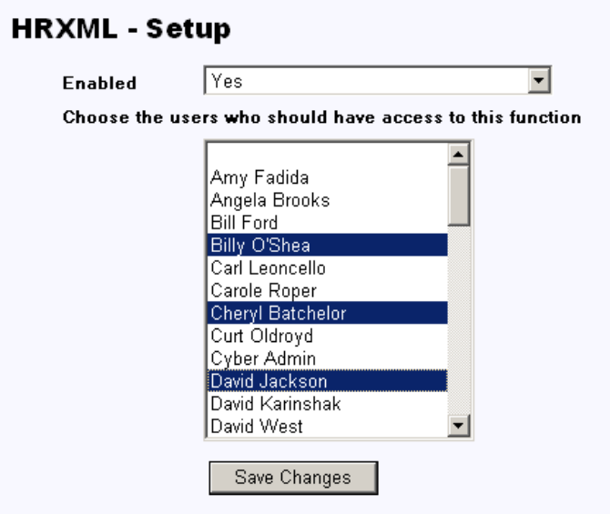

Question | Response | Result
Enabled? | Yes | All of HR-XML-specific pages and menu items will be added in Cyber Recruiter.
Enabled? | Yes | Additional Action Needed: Highlight the Users in the Drop-Down List who should have access to the HR-XML-specific functions in Cyber Recruiter. Hold the CRTL key down to select more than one User.
Enabled? | No | Users will not see any references to HR-XML in Cyber Recruiter.

Step 2: Verifying Code Tables
To accomplish this step, the Administrator needs verify the HR-XML code tables are up-to-date in Admin > Codes > HR-XML. The two (2) code tables are Shift and Employment Level. They are not required to transfer data an HR-XML file. The Shift code table contains the possible shifts that a person might work (1st, 2nd, 3rd, etc.) and the Employment Level contains whether a new employee is Full Time, Part Time, Temporary, etc.

Daily Use – Transferring Applicants to HR-XML

Step 1: Prepare the Applicant & Verify Required Fields
Once the HR-XML setup is enabled, a HR-XML Page in the Applicant File will be viewable.

Find the Applicant to export - Applicants > Find Applicant. Once the Applicant is located, use the HR-XML Page to enter data that does not already exist in the Cyber Recruiter product. Even though these fields are not required, Employee #, Hire Date, Employment Level, and Annual Salary are typically required for any HR product.

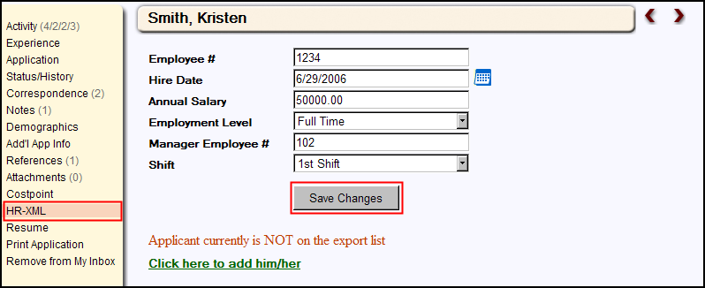

Step 2: Add Record to the Export File
Click on the green link at the bottom of the page to add this Applicant to the export file. The red indicator will change to indicate whether the applicant is on the list of applicants to be exported. In this example, the link has been clicked.

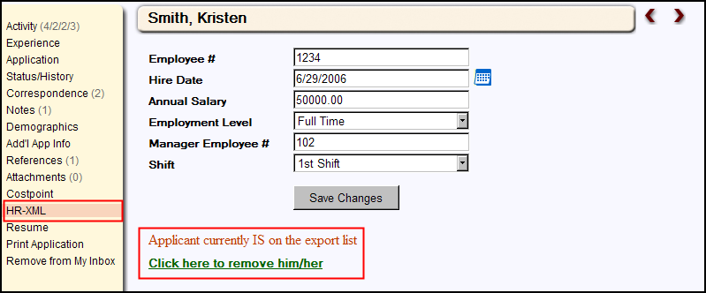

Step 3: Generate Export File
After verifying and adding the Applicant to the export file, from the main menu bar select Applicants > HR-XML Export to generate the export file.

The Employee ID number is pulled from the Applicant File (Employee File) > HR-XML Page > Employee ID Field.

This table displays the Applicants who have been added to the export file via the Applicant File > HR-XML Page. To add additional applicant to the list, press the Add button and find the Individual. To remove Applicants from the list, check the box at the end of the Individual name click the Delete Selected button. Using the Select All or Deselect All links at the top will place checkmarks or remove check marks next to everyone’s record. Everyone listed here will be included in the export file.

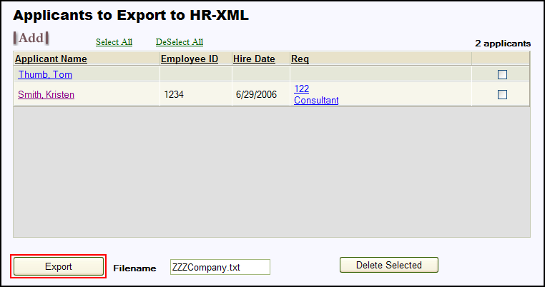

Click the Export button to create the export file. Enter the name of the file in the Filename field. Cyber Recruiter will save the last export file created. However, this file will be overwritten each time the export process is run.

Step 4: Verify Results

Correct Errors
This page which appears lists any errors that occurred during the export process. If the error log indicates that some employees are missing information, the information for those employees should be entered and another export performed. Click the Print link to print a report as needed t and click the Individual name to enter the file o make the necessary changes. Re-run the export process; the export process can be run as many times as needed to obtain an error free file.

save file
If the error log indicates that all Applicants/Employees were Exported Successfully, right-click the indicated link and choose Save Target As to download the XML file created to the network or hard drive. This file is then imported into HR System necessary. Click on the Return to HR-XML Export Page to finish the process.

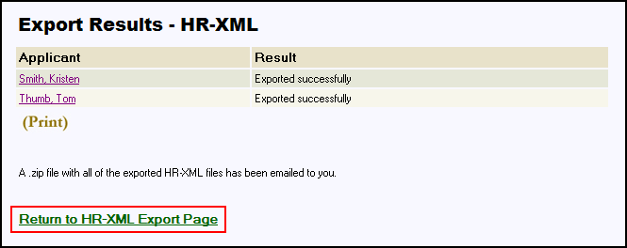

Step 5: Prepare Export List for Next Batch
To prepare the HR-XML Export page for the next batch of new hires, press the Select All link to place a checkmark next to the Applicant’s names. Then, press the Delete Selected button to remove them from this list.

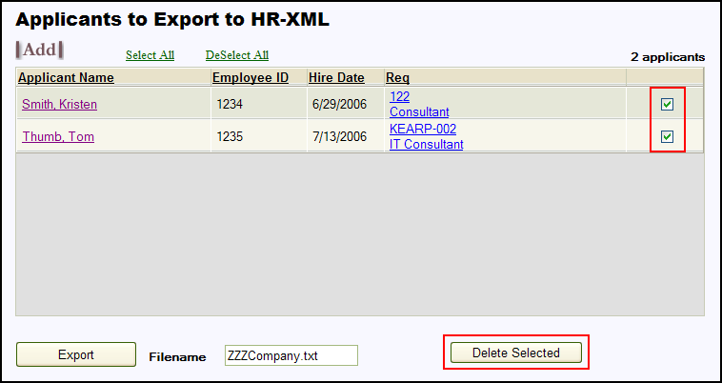

Step 6: Import into HR-XML SupportED Product
Using the tools available via your HR-XML supported product, browse to the file generated by Cyber Recruiter. Import this file and verify the data for accuracy upon bringing the file into the system.

Appendix A – Importing Code Tables

The Import Code Tables menu item of Admin > Processes allows the ability to import ASCII text files of code into any the Cyber Recruiter code tables. The file must be a .csv file with only two columns: first column represents the Code and the second column represents the Description. (Note: Neither column can have commas in them BUT they the columns will need to be separated by commas.)

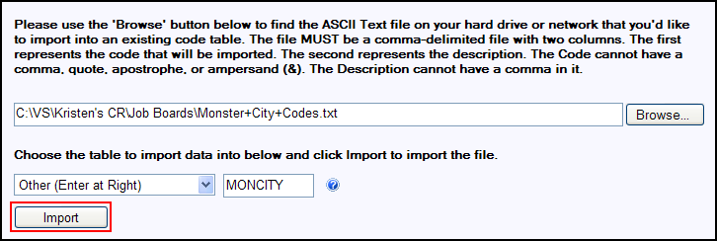

Browse | This button allows Users to find the ASCII text file on a computer hard drive or network. (Note: the specific instructions listed are necessary for successful importation of codes; otherwise all codes might not make it in the database.)
Drop-Down List | This drop-down list contains all the available code tables the ASCII Text file can be imported.
Open Text Field | Field Description: If the desired code tables are not listed in the drop-down list, use the last option in the list, Other (Enter at Right). This make the other field activated and a table abbreviation code should be entered. Below is a list of codes that can be used to upload the code tables for the appropriate HR and Payroll systems.

